NAIROBI SCHOOL
NAME……………………………………………………………………………………….Adm No……………………Stream………………..
Candidate’s Signature………………………………. Date…………………………………………
231/2
BIOLOGY
Paper2
(THEORY)
AUGUST/SEPTEMBER 2022
TIME: 2 HOURS
MOCK EXAMINATION
INSTRUCTIONS TO CANDIDATES
- Write your name and index number in the spaces provided above.
- Sign and write the date of the examination in the spaces provided above.
- This paper consists of two sections; A and B.
- Answer all the questions in section A in the spaces provided.
- In section B answer 6 (compulsory) and either question 7 or 8 in the spaces provided.
- This paper consist of 12 printed pages
- Candidates should check the question paper to ascertain that all the pages are printed as indicated and that no question is missing.
- Candidates should answer all questions in English.

FOR EXAMINER’S USE ONLY
section | Question | Maximum Score | Candidate’s Score
A | 1 | 8
 | 2 | 8
 | 3 | 8
 | 4 | 8
 | 5 | 8
B | 6 | 20
 | 7 | 20
 | 8 | 20
Total score |  | 80

SECTION A: (40 MARKS)
Answer all questions in this section in the spaces provided.
1. In a certain species of plants which is normally green, a recessive gene for color (n) causes the plant to be white in color. Such plants die at early age. In the heterozygous state, the plants are pale green in color but grow to maturity.
- Give a reason for the early death of the plants with homozygous recessive gene. (2 marks)
……………………………………………………………………………………………………………………………………………………………………………………………………………………………………………………………………………………………………………………………………………………………………………………………………………………………………………………..
- If a normal green plant was crossed with a pale green, what would be the genotype of the first filial generation (F1)? (4 marks)

- If heterozygous plant was self-pollinated and the resulting seeds planted, work out the proportion of their offspring that would grow to maturity. (4 marks)

2. In an experiment a student added drops of his own blood into two separate test tubes, R and T containing 10 cm³ of a salt solution; then shook the test tubes thoroughly to mix the contents. After 15 minutes he noticed that he could see through test tube T but not through R. After further 15 minutes he could still not see through test tube R.
- Given that one solution was 0.2% sodium chloride and the other was 1.4% sodium chloride, identify the solution in each of the test tubes R and T. Explain your answers. ( 2marks)
……………………………………………………………………………………………………………………………………………………………………………………………………………………………………………………………………………………………………………………………………………………………………………………………………………………………………..
- Account for the results in test tube T. (3 marks)
…………………………………………………………………………………………………………………………………………………………………………………………………………………………………………………………………………………………………………………………………………………………………………………………………………………………………………………………………………………………………………………………………………………………………………………..
- Draw the possible appearances of one of the cells in the test tube R when observed under a light microscope. ( 2marks)
…………………………………………………………………………………………………………………………………………………………………………………………………………………………………………………………………………………………………………………………………………………………………………………………………………………………………………………………………………………………………………………………………………………………………………………….
- Suggest the name of the process that has occurred to cells in each of the test tubes R and T. ( 2 marks)
Test tube T…………………………………………………………………………………………………………………………..
Test tube R…………………………………………………………………………………………………………………………..

3. A group of students set up the following experiments to investigate the factors that affect enzymes.

Tube | Contents of the tube and condition.
1 | Egg white and amylase at 36⁰C.
2 | Starch, dilute hydrochloric acid and amylase at 36⁰C.
3 | Starch and amylase at 36⁰C
4 | Starch and amylase at 60⁰C

- Identify the property of enzymes being investigated in tubes 1 and 2. ( 2marks)
Tube 1……………………………………………………………………………………………………………….
Tube2………………………………………………………………………………………………………………..
- After 3 hours the students tested the content in the four tubes for starch. They obtained the following results in tubes 2, 3 and 4.
Tube 2-Blue black color
Tube 3-Brown color of iodine solution retained
Tube 4-Blue black color.
Account for the results obtained in tube 3 and 4. (2 marks)
………………………………………………………………………………………………………………………………………………………………………………………………………………………………………………………………………………………………………………………………………………………………………………………………………………………………
- What results would you expect in tube 3 if the temperature was maintained at 5⁰C? Give a reason for your answer. ( 2marks)
………………………………………………………………………………………………………………………………………………………………………………………………………………………………………………………………………………………………………………………………………………………………………………………………………………………………
- Name two enzymes found in the pancreatic juice. (2marks)
……………………………………………………………………………………………………………………………………………………………………………………………………………………………………………………………………………………………………………………………………………………………………………………………………………………………..
4. The photograph below shows how different bones articulate in part of a mammalian body. Examine it and answer the the questions that follow.
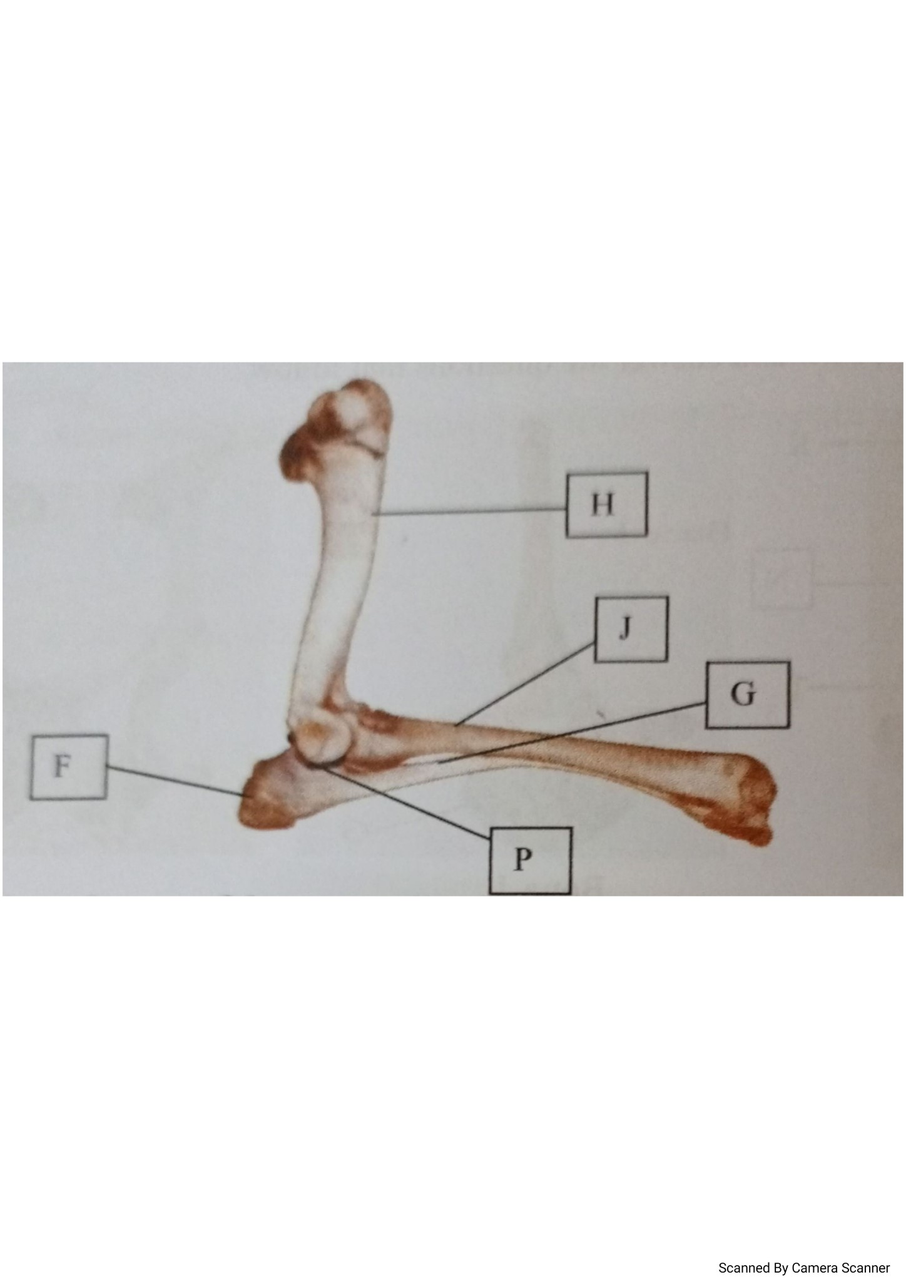
- Name the part of mammalian body from which the bones were obtained. (1 mark)
………………………………………………………………………………………………………………………………………………..
- Name bones labelled H and J. ( 2marks)
Bone H……………………………………………………………………………………………………………………….
Bone J………………………………………………………………………………………………………………………..
- (i) Name the type of joint formed at the proximal end of the bone labelled H. (2 marks)
Joint ………………………………………………………………………………………………………………………………………
(ii) Give a reason for your answer in c (i) above.
……………………………………………………………………………………………………………………………………………………………………………………………………………………………………………………………………………………………..
- State one function of the part labeled F. ( 1 mark)
………………………………………………………………………………………………………………………………………………………………………………………………………………………………………………………………………………………………
- Name the structure on the mammalian body that performs the same function as part F. ( 1mark)
………………………………………………………………………………………………………………………………………..........
- State one function of the fluid found in part labeled P. (1 mark)
…………………………………………………………………………………………………………………………………………
5. A group of students set-up the apparatus below to investigate a physiological process. Temperature changes were recorded for a period of one week.

- (i) State the observation made in temperature reading in flask X. ( 1mark)
………………………………………………………………………………………………………………………………………………

(ii) Give a reason for the observation made in (a) (i) above. (1 mark)
……………………………………………………………………………………………………………………………………………………………………………………………………………………………………………………………………………………………..
- Why are micro-organisms killed in boiled beans? (1mark)
………………………………………………………………………………………………………………………………………………………………………………………………………………………………………………………………………………………………
- Give a reason as to why the flasks were not fully filled with seeds. (1 mark)
……………………………………………………………………………………………………………………………………………………………………………………………………………………………………………………………………………………………..

- Why were flasks inverted upside down? ( 1mark)
……………………………………………………………………………………………………………………………………………………………………………………………………………………………………………………………………………………………..

- Why was the experiment carried out in thermos flask? (1 mark)
……………………………………………………………………………………………………………………………………………………………………………………………………………………………………………………………………………………………..

- State the changes you would expect in the composition of gases in the flask after several hours of the experiment. (2 marks)
………………………………………………………………………………………………………………………………………………………………………………………………………………………………………………………………………………………………

SECTION B (40MARKS)
Answer question 6 (COMPULSORY) and either question 7 or 8 in the spaces provided.
6. An experiment was done to determine the concentration in the blood of two hormones X and Y produced in the ovaries of a healthy woman aged 30years within a period of 28 days. The results obtained are as shown in the table below.

Time(days) | Concentration of hormone X  (arbitrary units) | Concentration of hormone Y (arbitrary units)
2 | 5 | 4
4 | 12 | 4
6 | 18 | 4
8 | 28 | 4
10 | 40 | 4
12 | 56 | 4
14 | 24 | 4
16 | 20 | 9
18 | 24 | 20
20 | 24 | 36
22 | 22 | 48
24 | 16 | 32
26 | 8 | 24
28 | 3 | 4

- Using same axes, plot a graph of the concentration of hormone X and Y against time. (7 marks)

- Suggest the identity of the hormones X and Y. (2 marks)
X………………………………………………………………………………………………………………………………………………
Y………………………………………………………………………………………………………………………………………………
- When was the concentration of hormones X and Y equal? (1 mark)
………………………………………………………………………………………………………………………………………………
- Briefly describe three features and mechanisms that hinder self-pollination and self-fertilization in flowering plants. (6 marks)
…………………………………………………………………………………………………………………………………………………………………………………………………………………………………………………………………………………………………………………………………………………………………………………………………………………………………………………………………………………………………………………………………………………………………………………………………………………………………………………………………………………………………………………………………………………………………………………………………………………………………………………………………………………………………………………………………………………………………………………………………………………………………………………………………………………………………………………………………………………………………………………………….
- Explain the role played by the hormones X and Y during menstrual cycle. (4 marks)
X……………………………………………………………………………………………………………………………………………………………………………………………………………………………………………………………………………………………………………………………………………………………………………………………………………………………………………….
Y………………………………………………………………………………………………………………………………………………………………………………………………………………………………………………………………………………………………………………………………………………………………………………………………………………………………………………
7. Describe the role of red blood cells transport of:
- Oxygen. ( 6 marks)
………………………………………………………………………………………………………………………………………………………………………………………………………………………………………………………………………………………………………………………………………………………………………………………………………………………………………………………………………………………………………………………………………………………………………………………………………………………………………………………………………………………………………………………………………………………………………………………………………………………………………………………………………………………………………………………………………………………………………………………………………………………………………………………………………………………………………………………………………………………………………………………………………………………………………………………………………………………………………………………………………………………………………………………………………………………………………………………………………………………………………………………………………………………………………………………………………………………………………………………………………………………………………………………………
- Carbon (IV) oxide. ( 14 marks)
………………………………………………………………………………………………………………………………………………………………………………………………………………………………………………………………………………………………………………………………………………………………………………………………………………………………………………………………………………………………………………………………………………………………………………………………………………………………………………………………………………………………………………………………………………………………………………………………………………………………………………………………………………………………………………………………………………………………………………………………………………………………………………………………………………………………………………………………………………………………………………………………………………………………………………………………………………………………………………………………………………………………………………………………………………………………………………………………………………………………………………………………………………………………………………………………………………………………………………………………………………………………………………………………………………………………………………………………………………………………………………………………………………………………………………………………………………………………………………………………………………………………………………………………………………………………………………………………………………………………………………………………………………………………………………………………………………………………………………………………………………………………………………………………………………………………………………………………………………………………………………………………………………………………………………………………………………………………………………………………………………………………………………………………………………………………………………………………………………………………………………………………………………………………………………………………………………………………………………………………………………………………………………………………………………………………………………………………………………………………………………………………………………………………………………………………………………………………………………………………………………………………………………………………………………………………………………………………………………………………………………………………………………………………………………………………………………………………………………………………………………………………………………………………………………………………………………………………………………………………………………………………………………………………………………………………………………………………………………………………………………………………………………………………………………………………………………………………………………………………………………………………………………………………………………………………………………………………………………………………………………………………………………………………………………………………………………………………………
8. (a) Explain the role of Antidiuretic hormone when there is less water in the human body. (8 marks)

………………………………………………………………………………………………………………………………………………………………………………………………………………………………………………………………………………………………………………………………………………………………………………………………………………………………………………………………………………………………………………………………………………………………………………………………………………………………………………………………………………………………………………………………………………………………………………………………………………………………………………………………………………………………………………………………………………………………………………………………………………………………………………………………………………………………………………………………………………………………………………………………………………………………………………………………………………………………………………………………………………………………………………………………………………………………………………………………………………………………………………………………………………………………………………………………………………………………………………………………………………………………………………………………………………………………………………………………………………………………………………………………………………………………………………………………………………………………………………………………………………………………

(b) Describe the process of photosynthesis. (12 marks)
…………………………………………………………………………………………………………………………………………………………………………………………………………………………………………………………………………………………………………………………………………………………………………………………………………………………………………………………………………………………………………………………………………………………………………………………………………………………………………………………………………………………………………………………………………………………………………………………………………………………………………………………………………………………………………………………………………………………………………………………………………………………………………………………………………………………………………………………………………………………………………………………………………………………………………………………………………………………………………………………………………………………………………………………………………………………………………………………………………………………………………………………………………………………………………………………………………………………………………………………………………………………………………………………………………………………………………………………………………………………………………………………………………………………………………………………………………………………………………………………………………………………………………………………………………………………………………………………………………………………………………………………………………………………………………………………………………………………………………………………………………………………………………………………………………………………………………………………………………………………………………………………………………………………………………………………………………………………………………………………………………………………………………………………………………………………………………………………………………………………………………………………………………………………………………………………………………………………………………………………………………………………………………………………………………………………………………………………………………………………………………………………………………………………………………………………………………………………………………………………………………………………………………………………………………………………………………………………………………………………………………………………………………………………………………………………………………………………………………………………………………………………………………………………………………………………………………………………………………………………………………………………………………………………….

