AGRICULTURE
443/1

PAPER 1
TIME: 2 HOURS

NAME _ADM_ INDEX NO

INTERNAL POST MOCK 2022 FINAL

INSTRUCTIONS TO CANDIDATES:

(a) Write your name and Index number in the spaces provided above.
(b) Sign and write the date of examination in the spaces provided above.
(c) This paper consists of THREE sections A, B and C.
(d) Answer ALL questions in Section A and B.
(e) Answer any TWO questions in section C.
(f) Answers should be written in the spaces provided.
(g) This paper consists of 8 printed pages.
(h) Candidates should check the question paper to ascertain that all the pages are printed as indicated and no questions are missing.
(i) Candidates should answer the questions in English.

FOR EXAMINER’S USE ONLY
SECTION | QUESTIONS | MAX. SCORE | CANDIDATE SCORE
A | 1 – 15 | 30
B | 16 – 20 | 20
C |  | 20
 |  | 20
Total  Score |  | 90

SECTION A (30 MARKS)
Answer ALL Questions in the Spaces Provided

1. Differentiate between olericulture and pomoculture. (2mks)

……………………………………………………………………………………………………………

…………………………………………………………………………………………………………….

2. Give four reasons why a well drained soil is suitable for crop production. (2mks)

……………………………………………………………………………………………………………

……………………………………………………………………………………………………………

……………………………………………………………………………………………………………

…………………………………………………………………………………………………………….

3. State four reasons for deep ploughing during land preparation. (2mks)

……………………………………………………………………………………………………………

……………………………………………………………………………………………………………

……………………………………………………………………………………………………………

…………………………………………………………………………………………………………..

4. Name four types of water pumps which can be used on the farm. (2mks)

……………………………………………………………………………………………………………

……………………………………………………………………………………………………………

……………………………………………………………………………………………………………

……………………………………………………………………………………………………………

5. State four characteristics that make a crop suitable for green manuring. (2mks)

……………………………………………………………………………………………………………

……………………………………………………………………………………………………………

……………………………………………………………………………………………………………

……………………………………………………………………………………………………………

6. List any four pieces of information which should be shown on Health record. (2mks)

……………………………………………………………………………………………………………

……………………………………………………………………………………………………………

………………….…………………………………………………………………………………………

……………………………………………………………………………………………………………
7. Give four reasons for seed selection in crop production. (2mks)

……………………………………………………………………………………………………………

……………………………………………………………………………………………………………

……………………………………………………………………………………………………………

……………………………………………………………………………………………………………

8. List five management practices carried out on a kale nursery two weeks after its establishment. (2½mks)
……………………………………………………………………………………………………………

……………………………………………………………………………………………………………

……………………………………………………………………………………………………………

……………………………………………………………………………………………………………

…………………………………………………………………………………………………………….

9. Differentiate between rogueing and thinning. (2mks)

……………………………………………………………………………………………………………

…………………………………………………………………………………………………………….

10. Name three diseases that attack cabbage. (1½mks)

……………………………………………………………………………………………………………

……………………………………………………………………………………………………………

……………………………………………………………………………………………………………

11. State four ecological requirements of tomatoes. (2mks)

……………………………………………………………………………………………………………

……………………………………………………………………………………………………………

……………………………………………………………………………………………………………

……………………………………………………………………………………………………………

12. List four factors that will lower demand of a commodity. (2mks)

……………………………………………………………………………………………………………

……………………………………………………………………………………………………………

……………………………………………………………………………………………………………

……………………………………………………………………………………………………………

13. State four routine practices of care and management of trees. (2mks)

……………………………………………………………………………………………………………

……………………………………………………………………………………………………………

……………………………………………………………………………………………………………

…………………………………………………………………………………………………………….

14. State four ways by which a farmer can make efficient use of a pasture crop. (2mks)
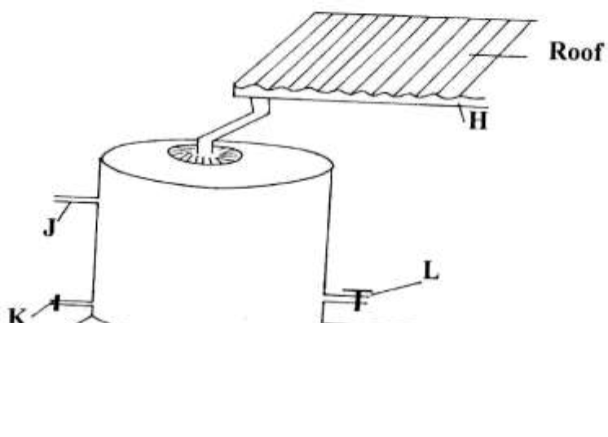……………………………………………………………………………………………………………

s & Free KCSE Prediction App | 726568677 | HighSchool

…………………………………………………………………………………………………………….

……………………………………………………………………………………………………………

…………………………………………………………………………………………………………….

15. List four pieces of information found on a title deed. (2mks)

……………………………………………………………………………………………………………

……………………………………………………………………………………………………………

……………………………………………………………………………………………………………

……………………………………………………………………………………………………………

SECTION B (20 MARKS)
Answer all questions in the spaces provided in this section

16. The illustration below shows a newly constructed cut-off drain. Study it and answer the questions that follow. 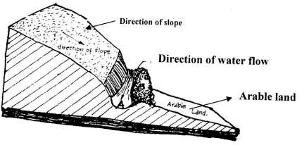

(a) (i) How can part of the structure labeled B be stabilized after it has been constructed? (1mk)
…………………………………………………………………………………………………….

(ii) Identify the part of the cut-off drain labeled A. (1mk)

……………………………………………………………………………………………........... (b) Describe the procedure of constructing a cut-off drain. (2mks)
……………………………………………………………………………………………………

……………………………………………………………………………………………………

……………………………………………………………………………………………………

……………………………………………………………………………………………………

17. The diagram below shows a house water storage tank. Study it and answer the questions that follow.

(a) Identify the parts of the tank labeled: H:……………………………………………………………………………… (1mk) K:……………………………………………………………………………… (1mk)
(b) Give the function of the part labeled J. (1mk)

……………………………………………………………………………………………………

…………………………………………………………………………………………………….

18. The experiment below was set to compare the porosity and water holding capacity of three different types of soils.
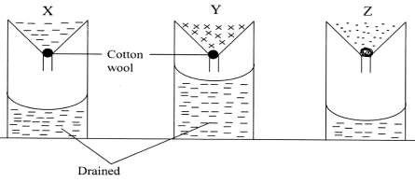

(i) Identify the soils in each of the following funnels labeled. (1½mks) X:………………………………………………………………………………………………. Y:………………………………………………………………………………………………. Z:………………………………………………………………………………………………..
(ii) Which of the types of soil can be said to have the highest porosity rate? (½mk)

……………………………………………………………………………………………

(iii) Give reasons for your answers in (ii) above. (2mks)

……………………………………………………………………………………………………

……………………………………………………………………………………………………

(iv) Which type of soil would be suitable for planting paddy rice? (1mk)

…………………………………………………………………………………………………..

(v) Explain your answer in (iv) above. (1mk)

……………………………………………………………………………………………………

…………………………………………………………………………………………………..

19. Below is a diagram of a Common East African Weed.

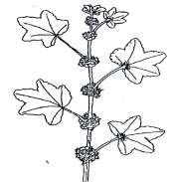

(i) Identify the weed illustrated above. (1mk)

…………………………………………………………………………………………………..

(ii) Give one harmful effect of the weed illustrated above to livestock. (1mk)

……………………………………………………………………………………………………

(iii) State two methods of controlling the weed illustrated above. (1mk)

……………………………………………………………………………………………………

…………………………………………………………………………………………………..

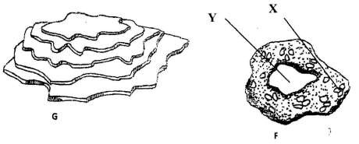20. The diagrams below illustrate some soil structures. Study them and answer the questions that follow.

(a) Identify the soil structures F and G. (1mk) F:……………………………………………………………………………………………….. G:………………………………………………………………………………………………..
(b) Name the part labeled X and Y in diagram F. (1mk) X:……………………………………………………………………………………………… Y:……………………………………………………………………………………………….
(c) State two ways through which structure G influence crop production. (2mks)

……………………………………………………………………………………………………

……………………………………………………………………………………………………

SECTION C (40 MARKS)

Answer any two questions from this section in the spaces provided

21. (i) Describe the field production of irrigated rice under the following sub-headings:

(a) Field preparation. (6mks)
(b) Water control (3mks) (c) Field management (5mks)
(ii) Describe the precautions taken while harvesting:

(a) Pyrethrum (3mks)

(b) Tea (3mks)

22. (a) Name two types of inventory records in the farm. (1mk) (b) Explain six importance of farm budgeting. (6mks) (c) The inventory for Kipsinende farm as at 01.06.2022
Kshs. Cash at hand 5,000
Broilers 30,000

Maize in store 7,000

Calves 15,000

Dairy cattle 120,000

Buildings 75,000

Machinery 95,000

Land 200,000

On the same day, the following information was obtained from the farmers records

Kshs. Interest payable 2,000
Cash in the bank 20,000

Taxes payable 750

Wages payable 5,600

Bank loan 213,000

Egg sales on credit 10,000

Milk sales on credit 13,000

Farm inputs purchased on credit 19,800

Vegetable sales on credit 5,000

Required: Prepare a balance sheet for the farm. (13mks)

23. (a) Outline the process of treating water for domestic use using chemical treatment

system. (12mks) (b) Explain five physical factors that increases the rate of soil erosion in a farm. (5mks) (c) Explain how monoculture leads to loss of soil nutrients. (3mks)
…………………………………………………………………………………………………..…

………………………………………………………………………………………………………

………………………………………………………………………………………………………

………………………………………………………………………………………………………

………………………………………………………………………………………………………

………………………………………………………………………………………………………

………………………………………………………………………………………………………

………………………………………………………………………………………………………

………………………………………………………………………………………………………

………………………………………………………………………………………………………

………………………………………………………………………………………………………

………………………………………………………………………………………………………

………………………………………………………………………………………………………

………………………………………………………………………………………………………

………………………………………………………………………………………………………

………………………………………………………………………………………………………

………………………………………………………………………………………………………

………………………………………………………………………………………………………

………………………………………………………………………………………………………

………………………………………………………………………………………………………

………………………………………………………………………………………………………

……………………………………………………………………………………………………..

…………………………………………………………………………………………………..…

………………………………………………………………………………………………………

………………………………………………………………………………………………………

………………………………………………………………………………………………………

………………………………………………………………………………………………………

………………………………………………………………………………………………………

………………………………………………………………………………………………………

………………………………………………………………………………………………………

………………………………………………………………………………………………………

………………………………………………………………………………………………………

………………………………………………………………………………………………………
………………………………………………………………………………………………………

………………………………………………………………………………………………………

………………………………………………………………………………………………………

………………………………………………………………………………………………………

………………………………………………………………………………………………………

………………………………………………………………………………………………………

………………………………………………………………………………………………………

………………………………………………………………………………………………………

………………………………………………………………………………………………………

………………………………………………………………………………………………………

………………………………………………………………………………………………………

………………………………………………………………………………………………………

………………………………………………………………………………………………………

………………………………………………………………………………………………………

………………………………………………………………………………………………………

………………………………………………………………………………………………………

………………………………………………………………………………………………………

………………………………………………………………………………………………………

………………………………………………………………………………………………………

………………………………………………………………………………………………………

………………………………………………………………………………………………………

………………………………………………………………………………………………………

………………………………………………………………………………………………………

