Name: …………………………………………………………… Adm No: ……………………………… Class: …………………………………………………………. Candidate’s Sign: ……………………. Date: ………………………………………………………….

443/1
AGRICULTURE PAPER 1

TIME: 2 HOURS

P0ST MOCK 2022 OCTOBER FINAL Kenya Certificate of Secondary Education (K.C.S.E.) FORM FOUR

INSTRUCTIONS TO CANDIDATES:

• Write your name and Index number and sign in the spaces provided above.

• Answer ALL the questions in section A and B in the spaces provided in this booklet.

• Answer any two questions in section C in the spaces provided after the last question.

F or E xami n er’s Use Only:

SECTION | QUESTIONS | MAXIMUM SCORE | CANDIDATES SCORE
A | 1 - 18 | 30

B | 19 - 22 | 20
C | 23 - 25 | 40
 | TOTAL | 90

SECTION A (30marks). Answer all Questions in this section.
1. a) State four characteristics of extensive farming system. (2mks)
………………………………………………………………………………………………………………….

………………………………………………………………………………………………………………….

………………………………………………………………………………………………………………….

…………………………………………………………………………………………………………………

………………………………………………………………………………………………………………….

b) List two disadvantages of small scale farming. (2mks)
………………………………………………………………………………………………………………….

………………………………………………………………………………………………………………….

………………………………………………………………………………………………………………….

2. Name two ways in which predators affect agricultural production. (1mk)
………………………………………………………………………………………………………………….

………………………………………………………………………………………………………………….

………………………………………………………………………………………………………………….

3. List down four factors that influence formation of soil. (2mks)
………………………………………………………………………………………………………………….

………………………………………………………………………………………………………………….

………………………………………………………………………………………………………………….

………………………………………………………………………………………………………………….

4. State two farming practices that bring about minimum tillage. (1mk)
………………………………………………………………………………………………………………….

………………………………………………………………………………………………………………….

………………………………………………………………………………………………………………….

5. Name the function of each of the following chemicals in water treatment.
a) Alum (1mk)
………………………………………………………………………………………………………………….

………………………………………………………………………………………………………………….

b) Soda ash (1mk)
………………………………………………………………………………………………………………….

………………………………………………………………………………………………………………….

6. State two importance of organic matter in the soil. (1mk)
………………………………………………………………………………………………………………….

7. State three reasons why green manure is not commonly used in the farms. (1 ½ mks)
………………………………………………………………………………………………………………….

………………………………………………………………………………………………………………….

………………………………………………………………………………………………………………….

………………………………………………………………………………………………………………….

8. State four uses of farm records. (2mks)
………………………………………………………………………………………………………………….

………………………………………………………………………………………………………………….

………………………………………………………………………………………………………………….

………………………………………………………………………………………………………………….

………………………………………………………………………………………………………………….

9. List three importance of phosphorous in crop growth. (1 ½ mks)
………………………………………………………………………………………………………………….

………………………………………………………………………………………………………………….

………………………………………………………………………………………………………………….

………………………………………………………………………………………………………………….

10. Name four significance of using seeds as planting materials. (2mks)
………………………………………………………………………………………………………………….

………………………………………………………………………………………………………………….

………………………………………………………………………………………………………………….

………………………………………………………………………………………………………………….

11. List two importance of tissue culture in propagating crops. (1mk)
………………………………………………………………………………………………………………….

………………………………………………………………………………………………………………….

………………………………………………………………………………………………………………….

12. State the difference between the following terms. (2mks)
a) Rogueing
………………………………………………………………………………………………………………….

………………………………………………………………………………………………………………….

b) Gapping
………………………………………………………………………………………………………………….

………………………………………………………………………………………………………………….

13. State four effects of applying too much nitrogenous fertilizer to crops. (2mks)
………………………………………………………………………………………………………………….

………………………………………………………………………………………………………………….

………………………………………………………………………………………………………………….

………………………………………………………………………………………………………………….

14. Name four disadvantages of communal land tenure system. (2mkS)
………………………………………………………………………………………………………………….

………………………………………………………………………………………………………………….

………………………………………………………………………………………………………………….

………………………………………………………………………………………………………………….

………………………………………………………………………………………………………………….

15. State four precautions farmers should observe when using agro-chemical for their safety and for environmental safety. (2mks)
………………………………………………………………………………………………………………….

………………………………………………………………………………………………………………….

………………………………………………………………………………………………………………….

………………………………………………………………………………………………………………….

………………………………………………………………………………………………………………….

………………………………………………………………………………………………………………….

………………………………………………………………………………………………………………….

16. State three harmful effects of pests on crops. (1 ½ mks)
………………………………………………………………………………………………………………….

………………………………………………………………………………………………………………….

………………………………………………………………………………………………………………….

………………………………………………………………………………………………………………….

………………………………………………………………………………………………………………….

17. State three qualities of a good manager in a farm setting. (1 ½ mks)
………………………………………………………………………………………………………………….

………………………………………………………………………………………………………………….

………………………………………………………………………………………………………………….

………………………………………………………………………………………………………………….

18. State two factors that influence the demand of a commodity. (1mk)
………………………………………………………………………………………………………………….

………………………………………………………………………………………………………………….

………………………………………………………………………………………………………………….

………………………………………………………………………………………………………………….

SECTION B (20 MARKS) Answer all questions in this section.
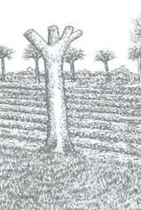19. Study the diagram below and answer the questions that follow

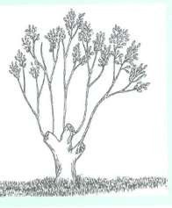A B
a) Identify the three harvesting methods shown in the diagrams above. (2mks)
………………………………………………………………………………………………………………….

………………………………………………………………………………………………………………….

………………………………………………………………………………………………………………….

………………………………………………………………………………………………………………….

b) Name four sites for agroforestry trees in the farm. (2mks)
………………………………………………………………………………………………………………….

………………………………………………………………………………………………………………….

………………………………………………………………………………………………………………….

………………………………………………………………………………………………………………….

20. The document below was obtained from one of the books of accounts in kimko’s farm. Study the
document and answer the questions that follow.
DAIRY CATTLE
DR |  |  |  | CR
Date | Particulars | Folio | Amount  Sh cts. | Date  2003 | Particulars | Folio | Amount  Sh cts.

Feb 20th  Feb 30th | Bought 2 bags of  dairy meal | 1 | 18,000.00 | Feb 10th | Sold 2 heifers | 1 | 12,000.00

a) Identify the book from which the above document was obtained. (1mk)
………………………………………………………………………………………………………………….

………………………………………………………………………………………………………………….

b) State four importance of keeping proper farm account records. (2mks)
………………………………………………………………………………………………………………….

………………………………………………………………………………………………………………….

………………………………………………………………………………………………………………….

………………………………………………………………………………………………………………….

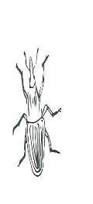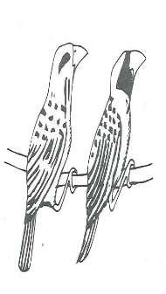21. The diagram below shows pests that affect crops when in the field. Study the diagrams and answer the questions that follow.
L
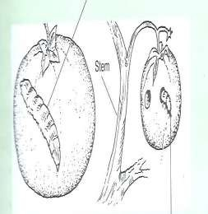J K

a) Identify the pest J, K and L. (3mks)
………………………………………………………………………………………………………………….

………………………………………………………………………………………………………………….

………………………………………………………………………………………………………………….

b) State two ways of controlling the pest labeled L above. (2mks)
………………………………………………………………………………………………………………….

………………………………………………………………………………………………………………….

………………………………………………………………………………………………………………….

c) State one crop attacked by the pest labeled J and K above. (2mks)
………………………………………………………………………………………………………………….

………………………………………………………………………………………………………………….

………………………………………………………………………………………………………………….

22. The Following weeds were found growing on a maize farm by a form four student. Study the weeds and answer the questions that follow.

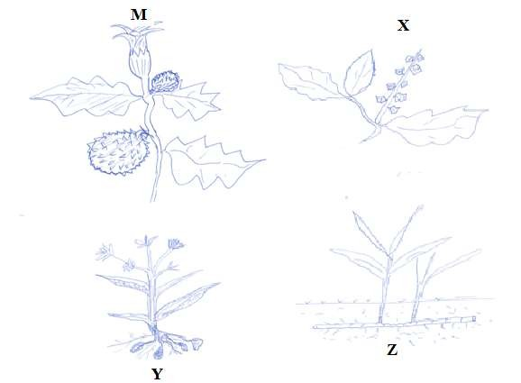
a) Name the weeds labeled X, Y and Z above. (3mks)

………………………………………………………………………………………………………………….

………………………………………………………………………………………………………………….

………………………………………………………………………………………………………………….

………………………………………………………………………………………………………………….

b) State one reason that makes each of the following weeds difficult to control. (2mks) (i) X
………………………………………………………………………………………………………………….

………………………………………………………………………………………………………………….

(ii) Z
………………………………………………………………………………………………………………….

………………………………………………………………………………………………………………….

c) State one reason why the weed labeled M should not be allowed to grow in the farm. (1mk)

………………………………………………………………………………………………………………….

………………………………………………………………………………………………………………….

………………………………………………………………………………………………………………….

………………………………………………………………………………………………………………….

………………………………………………………………………………………………………………….

………………………………………………………………………………………………………………….

SECTION C (40 marks)

Answer only two questions in this section

23. | a) Explain five cultural methods a farmer can use to control weeds. | (10mks)
 | b) State and explain five factors considered when establishing nursery bed site. | (10mks)

24. | a) Describe five ways in which a farmer may adjust to uncertainty and risks in the farm. | (10mks)
 | b) Explain five physical methods used to control crop pests in a crop land. | (10mks)

25. | a) State five types of information contained in a tittle deed. | (5mks)
 | b) State five methods used to control soil and water pollution. | (5mks)
c) State and explain five ways an entrepreneur can use to improve labour productivity in a farm.
(10mks)

…………………………………………………………………………………………………………………

………………………………………………………………………………………………………………….

………………………………………………………………………………………………………………….

………………………………………………………………………………………………………………….

…………………………………………………………………………………………………………………

………………………………………………………………………………………………………………….

…………………………………………………………………………………………………………………

………………………………………………………………………………………………………………….

………………………………………………………………………………………………………………….

………………………………………………………………………………………………………………….

………………………………………………………………………………………………………………….

………………………………………………………………………………………………………………….

………………………………………………………………………………………………………………….

………………………………………………………………………………………………………………….

………………………………………………………………………………………………………………….

………………………………………………………………………………………………………………….

………………………………………………………………………………………………………………….

………………………………………………………………………………………………………………….

………………………………………………………………………………………………………………….

………………………………………………………………………………………………………………….

………………………………………………………………………………………………………………….

………………………………………………………………………………………………………………….

………………………………………………………………………………………………………………….

………………………………………………………………………………………………………………….

………………………………………………………………………………………………………………….

………………………………………………………………………………………………………………….

………………………………………………………………………………………………………………….

………………………………………………………………………………………………………………….

………………………………………………………………………………………………………………….

………………………………………………………………………………………………………………….

………………………………………………………………………………………………………………….

………………………………………………………………………………………………………………….

………………………………………………………………………………………………………………….

………………………………………………………………………………………………………………….

………………………………………………………………………………………………………………….

………………………………………………………………………………………………………………….

………………………………………………………………………………………………………………….

………………………………………………………………………………………………………………….

………………………………………………………………………………………………………………….

………………………………………………………………………………………………………………….

………………………………………………………………………………………………………………….

………………………………………………………………………………………………………………….

………………………………………………………………………………………………………………….

………………………………………………………………………………………………………………….

………………………………………………………………………………………………………………….

………………………………………………………………………………………………………………….

………………………………………………………………………………………………………………….

………………………………………………………………………………………………………………….

………………………………………………………………………………………………………………….

