443/1 – AGRICULTURE PAPER 1 – MARKING SCHEME

1. Olericulture is the growing of vegetables while Pomoculture is the growing of fruits.
(Mark as a whole) (1 x 2 = 2mks)
2.
- Has improved soil structure.
- Has reduced leaching.
- Has improved water holding capacity.
- Has increased cation exchange capacity.
- Has high micro organisms which increases decomposition of organic mater which decompose to release nutrients. (4 x ½ = 2mks)
3.
- Facilitates aeration.
- Facilitates drainage.
- Breaks hard pans / facilitate water infiltration.
- Brings up leached nutrients.
- Facilitates development of deep rooted crops.
- Exposes lower soil layers to weathering.
- Exposes soil borne pests and pathogens.
- Removes deep rooted weeds. (4 x ½ = 2mks)
4.
- Centrifugal / Rotar dynamic pump
- Reciprocating / piston pump.
- Hydram pump
- Rotary pump (4 x ½ = 2mks)
5.
- Rapid growth rate.
- Production of abundant foliage.
- Rich in plant nutrients / leguminous / rich in nitrogen.
- Ability to decay quickly.
- Adaptable to wide range of conditions / hardy. (4 x ½ = 2mks)
6.
- Date of treatment.
- Symptoms of disease.
- Animals affected.
- Drugs which were used.
- Cost of treatment. (4 x ½ = 2mks)
7.
- To obtain seed suitable to ecological conditions.
- To obtain pure planting material.
- To increase germination percentage.
- To remove pests and disease infested planting material. (4 x ½ = 2mks)
8.
- Watering
- Weed control.
- Pricking out
- Pest control
- Disease control
- Hardening off (5 x ½ = 1½mks)
9.
- Rogueing is the uprooting and destruction of crops that are infested with pests and diseases. Thinning is the uprooting / removal of excess seedlings to allow space for the remaining seedlings. (Mark as a whole) (1 x 2 = 2mks)
10.

11.

12.

13.

14.

15.

- Damping off
- Black rot
- Downy mildew (3 x ½ = 1½mks)

- Altitude should be 0 – 2100m above sea level.
- Rainfall should range between 760 – 1300mm per year.
- Temperature should range between 18 – 290C
- The soil pH should be between 5.5 – 6.5 (4 x ½ = 2mks)

- High price of commodity.
- Taxation.
- Expected decrease in price of the commodity.
- Advertisement reduction.
- Decrease in population size.
- Reduced income of consumers / inflation.
- Lower tastes and preferences by consumer / reduced fashion of commodity.
- When price of substitute decreases. (4 x ½ = 2mks)

- Protection of trees.
- Pruning.
- Training.
- Grafting old trees. (4 x ½ = 2mks)

- Rotational grazing / controlled grazing.
- Proper stocking rate.
- Conserve excess pasture.
- Timely defoliation.
- Practice zero grazing.
- Graze different classes / species of animals. (4 x ½ = 2mks)

- The name and signature of owner of the land / identification number of owner.
- The size of land.
- The land parcel number.
- Type of owner, if any.
- Seal of issuing officer and signature of issuing officer.
- The date of registration. (4 x ½ = 2mks)

SECTION B

16. (a) (i) By planting grass / suitable vegetation. (ii) Channel / trench.
(b) - Measure and mark the layout of drain.
- Dig and remove soil from the channel and heap it on the lowerr side of the drain. (4x ½ = 2mks)
17. (a) H – Gutter (1 x 1 = 1mk) K – Drainage pipe (1 x 1 = 1mk)
(b) Let out excess water (1 x 1 = 1mk)

18. (i) X – Loam
Y – Sand
Z – Clay (3 x ½ = 1½mks) (ii) Soil Y (sandy) ( ½ mk)
(iii) It has drained the highest amount of water as opposed to others. (1mk)
(iv) Soil Z / Clay soil (1mk) (v) It is not easily drained / does not loose water easily when flooded for rice production.
19. (i) - Mallow weed / Malva verticillata. (1 x 1 = 1mk) (ii) - Poisonous / Toxic to livestock. (1 x 1 = 1mk) (iii) - Mechanical (Acc. any specific method)
- Biological
- Cultural (Acc. any specific method)
- Chemical (Acc. any correct chemical)
Rej. Legislative. (any 2 x ½ = 1mk) (b) Presence of underground storage structures / rhizomes which are difficult to control. (1mk)

20. (a) F – Granular structure (½mk) G – Platy structure (½mk)

(b) X – Humus with clay (½mk) Y – Air space (½mk)

(c) - Impedes drainage / water infiltration.
- Prevent root penetration.
- Influence soil aeration. (any 2x1 = 2mks)

SECTION C

21. (i) (a) Field preparation
- The field should be cultivated to a fine tilth.
- Construct / repair bund around the field.
- Flood the field 4 days after transplanting.
- Flood the field up to 10cm above the surface.
- Puddle the soil to the required tilth / rotavate the soil.
- Level the field by dragging a board to obtain level seedbed.
- Construct inlet and outlet. (5 x 1 = 5mks)

(b) Water control
- Increase water level from 5cm to 15cm.
- Water is increased gradually.
- Allow water to flow slowly through the fields / allow fresh water at 2 – 3 weeks interval. (3 x 1 = 3mks)
(c) Field management
- Control weeds by uprooting / use of appropriate herbicide
- Control birds by scaring or by destroying breeding colonies.
- Water should be changed every 2 – 3 weeks / let water flow slowly through the field.
- Drain water 3 weeks before harvesting / when heads turn down.
- Maintain level of water at 1/3 height of plants until 3 weeks before harvesting.
- Top dress with sulphate of ammonia at 250kg/ha in two portions.
- Top dress just before transplanting and after 40 days.
- Control diseases i.e. Anthracnose by growing resistant varieties, use clean seeds. Or bacteria blight uprooting and destroying infected plants or spray with colliar oxychloride. (5x1 = 5mks)

(ii) (a) Pyrethrum
- Picked flowers are put into open woven baskets to allow proper ventilation.
- Only dry flowers are picked to avoid fermentation and heating up.
- Flowers are not compacted in the basket to avoid heating up and fermentation.
(3x1 = 3mks)
(b) Tea
- Tea leaves are not compressed in a basket.
- Harvested tea leaves are kept cool under a shade as harvesting continues.
- Tea leaves are delivered to the factory on the same day after harvesting. (1x3 = 3mks)
22. (a) - Consumable goods inventory records.
- Permanent goods inventory records. (2 x ½ = 1mk)
(b)

- Helps in decision making
- Enables the farmers to predict future returns.
- Helps farmer to avoid incurring losses by investing in less profitable enterprises.
- It ensures a periodic analysis of the farm business.
- It acts as a record which can be used for future reference.
- It pin points efficiency or weakness in farm operations.
- Enables farmers to secure loans from financial institutions. (6 x 1 = 6mks)

(c)

KIPSINENDE FARM BALANCE SHEET
AS AT 01 – 06 – 2022

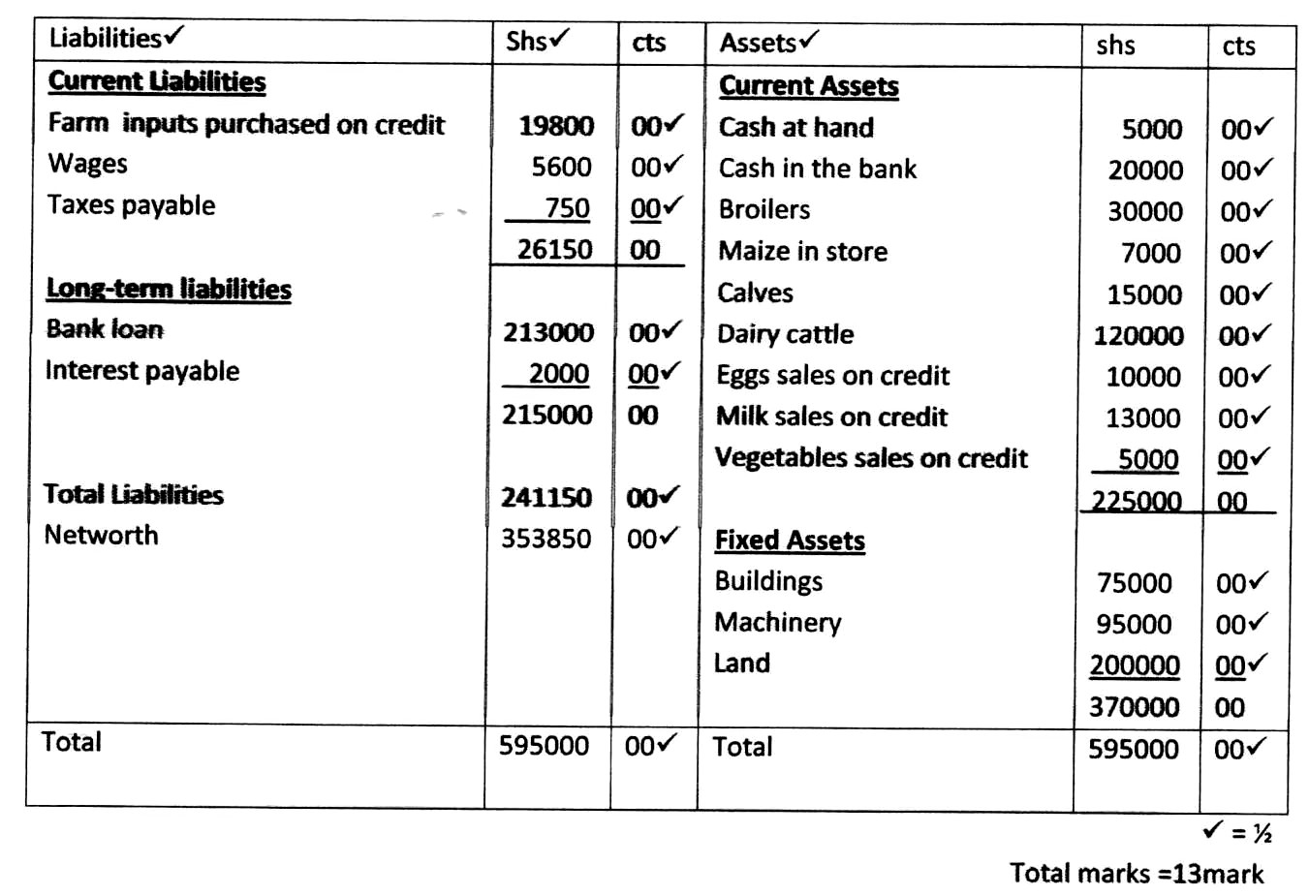23. (a)

• Stage I – Filtration at the water intake.
(½ x 26)
- Water is made to pass through series of sieves so that large particles are trapped.
• Stage II – Softening of water
- Water is mixed with soda ash (NAHCO2) in small tank to soften it.
• Stage III – Coagulation and sedimentation
- Allum is added to water to facilitate coagulation and sedimentation.
- Water stays in the tank for 36 hours to kill bilharzias.
- Tanks open to remove bad small / odour and for aeration.
• Stage IV – Filtration
- Water passes through filtration tank where all remains solid particles removed.
• Stage V – Chlorination
- Water enters chlorination tank where chlorine is added to kill germs.
• Stage VI – Storage
- Treated water is stored in large tanks before distribution.
(stage mentioned – 1mk, explanation – 1mk) (6 x 2 = 12mks)
(b)

(c)

(i) Nature of soil e.g. sandy soils are easily eroded whereas clay is resistant to erosion. (ii) Shape of the land – the steeper the shape of the land the higher the erosivity.
(iii) Rainfall intensity – the higher the intensity of rain the higher the erosion. (iv) Rainfall amount – the higher the amount of rainfall the higher the erosion.
(v) Strength of wind – the stronger the wind the higher the erosive power.
(vi) Bareness of the land – bare land are prone to erosion.
(5 explained points) (5 x 1 = 5mks) NB: No mark for just stating.
- One type of nutrient is used leading to its exhaustion.
- Nutrient is used from a certain zone where roots can reach.
- Leads to build up of certain pests and diseases. (3 x 1 = 3mks)

