231/2 - BIOLOGY - Paper 2

2 Hours

NAME…………………………………………………………………ADM…………CLASS……………….

2022 TRIAL 2 JULY INTERNAL EXAMINATION

Kenya Certificate of Secondary Education (K.C.S.E)

INSTRUCTIONS TO CANDIDATES
- Write your name and Index Number in the spaces provided above.
- This paper consists of two sections. Section A and section B.
- Answer ALL questions in section A in the spaces provided. In section B answer question 6 (compulsory) and either question 7 or 8 in the spaces provided after question 8.
- This paper consists of 10 Printed pages. Candidates should check the question paper to ensure that all the papers are printed as indicated and no questions are missing
For Examiners use only.
Section | Question | Maximum score | Candidates score
A | 1 | 8
 | 2 | 8
 | 3 | 8
 | 4 | 8
 | 5 | 8
B | 6 | 20
 | 7 | 20
 | 8 | 20
 | Total score | 80

SECTION A. 40 MARKS
Answer all the Questions in this section.

1. The diagram below illustrates an experimental set up to compare relative amounts of a gas in inhaled air and exhaled air.

a) On the diagram, show with arrows the direction of movement of inhaled and exhaled air into and out of the mouth. (2mks).
b) What is the name of the gas being investigated in the experiment (1mk) ………………………………………………………………………………………………………………………………………………………………………………………………………………………………………………
c) What will happen to the lime water in. (2mks)
Boiling tube A? ……………………………………………………………………………………………………………………………………………………………………………………………………………………………………
Boiling tube B?
……………………………………………………………………………………………………………………………………………………………………………………………………………………………………
d) Explain the observations made in (c) above. (3mks). ………………………………………………………………………………………………………………………………………………………………………………………………………………………………………………………………………………………………………………………………………………………………………………………………………………………………………………………………………………………………………………………………………………………………………………………………………………………
2. A human gene which is Y-linked controls premature baldness. One allele leads to normal hair pattern while the other produces premature baldness
- What are alleles? (1mark)
……………………………………………………………………………………………………………………………………………………………………………………………………………………………………………...
b) If a man with premature baldness marries, work-out the phenotypes of his children. (Use letter R to represent gene for premature baldness). (4 marks)

c) Explain why this trait is not observed in females (2marks)
…………………………………………………………………………………………………………………………………………………………………………………………………………………………………………………………………………………………………………………………………………………………………………………………………………
d) Give one other trait in man that is Y—linked (1mark)
………………………………………………………………………………………………………………………………………………………………………………………………………………
- a) What is active transport? (1mk) ………………………………………………………………………………………………………………………………………………………………………………………………………………………………………………………………………………………………………………………………………………………………………
- State three factors that increase the rate of active transport. (3mks) ………………………………………………………………………………………………………………………………………………………………………………………………………………………………………………………………………………………………………………………………………………………………………………………………………………………………………………………………

- Give two roles of osmosis in animals. (2mk)
………………………………………………………………………………………………………………………………………………………………………………………………………………………………………………………………………………………………………………………………………………………………………………………………………………………………………………………………………………………………
- What would happen if a plant cell is placed in a hypotonic solution (2mks)
………………………………………………………………………………………………………………………………………………………………………………………………………………………………………………………………………………………………………………………………………………………………………
4. The diagram below shows two fused bones of a mammal.
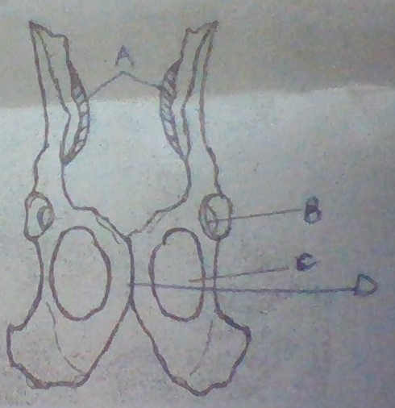
- Identify the fused bones. (1mk)
…………………………………………………………………………………………………………..
- Name:
i) The bone that articulates at the point labelled A. (1mk)
…………………………………………………………………………………………………………………………………………………………………………………………………
ii) The structure labelled B. (1mk)
……………………………………………………………………………………………………………………………………………………………………………………………………………………………………
- State the type of joint formed at structure B. (1mk)
……………………………………………………………………………………………………………………………………………………………………………………………………………………………………
- (i) Name: the structure labelled C (1mk) ……………………………………………………………………………………………………………..
ii) State two functions of the structure named in d(i) above (2 mks)
……………………………………………………………………………………………………………………………………………………………………………………………………………………………………
- i) Name the structure labelled D (1mk)
…………………………………………………………………………………………………………………
ii) State what happens to the structure during childbirth. (1mk)
………………………………………………………………………………………………………………….

5. Use the diagram below to answer the questions that follow;

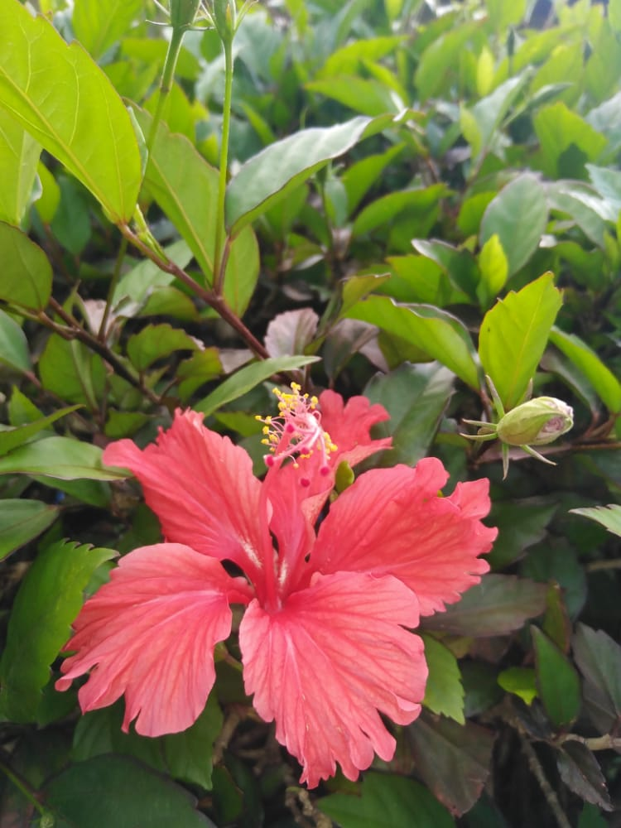

- Name the class the plant belongs to. ( 1mk)
…………………………………………………………………………………………
- Give three OBSERVABLE characteristics that place the plant to the class named in (a)above ( 3mks)
………………………………………………………………………………………………………………………………………………………………………………………………………………………………………………………………………………………………………………………………………………………………………………………………………………………………………………………………
- If a cross section was done on the young stem, draw and label the section observed. (3mks)

SECTION B (40 MARKS)
Answer question 6 (compulsory) and either 7 or 8
6 .In an ecological study, a grasshopper population and that of crows was estimated in a certain grassland area over a period of one year. The results are as shown in the table below.
Months | J | F | M | A | M | J | J | A | S | 0 | N | D
Number of adult grasshoppers x 10₂ | 90 | 20 | 11 | 25 | 2500 | 1652 | 120 | 15 | 10 | 35 | 192 | 456
Number of crows | 4 | 2 | 0 | 1 | 8 | 22 | 7 | 2 | 1 | 1 | 5 | 15
Amount of rainfall | 20 | 0 | 55 | 350 | 520 | 350 | 12 | 10 | 25 | 190 | 256 | 350

- (i) What is the relationship between the rainfall and grasshopper population?(1 mark) …………………………………………………………………………………………………………………………………………………………………………………………………………………………………………………………………………………………………………………………………………………………………………………………………………………………………………
(ii) Account for the relationship stated in a (i) above. (3 marks)
………………………………………………………………………………………………………………………………………………………………………………………………………………………………………………………………………………………………………………………………………………………………………………………………………………………………………………………………………….

- Explain the relationship between the grasshopper population and that of the crows. (3 marks)
………………………………………………………………………………………………………………………………………………………………………………………………………………………………………………………………………………………………………………………………………………………

(c) If the data was used in the construction of pyramid of numbers, what would be the trophic of;
(3 marks)
(i) Grasshoppers …………………………………………
(ii) Crows …………………………………………
(iii) The grass in the study area …………………………………………
(d) If the area studied was one square kilometer, state:
(i) one method that could have been used to estimate the crow population. (1 mark)
………………………………………………………………………………………………………
(ii) One method that could have been used to estimate the grasshopper population.(1mark)
………………………………………………………………………………………………………
(e) Suggest what would happen f a predator for grasshoppers entered the study area. (2 marks)
…………………………………………………………………………………………………………………………………………………………………………………………………………………………………………………………………………………………………………………………………………………………………………………………………………………………………………………………………………

- What is meant by the term carrying capacity? (1 mark)
………………………………………………………………………………………………………………………………………………………………………………………………………………………………………………………………………………………………………………………………………………………
(g) Why would the carrying capacity of wild animals in a woodland grassland be higher than that of cattle? (2 marks) ………………………………………………………………………………………………………………………………………………………………………………………………………………………………………………………………………………………………………………………………………………………..

(h) What is an ecosystem? (3 marks)
…………………………………………………………………………………………………………………………………………………………………………………………………………………………………………………………………………………………………………………………………………………………………………………………………………………………………………………………………………

7. Describe how water from the soil reaches the leaves of a tall tree and eventually to the atmosphere.
(20mks)
8. Explain how the human alimentary canal is adapted to perform its functions. (20mks).
…………………………………………………………………………………………………………………………………………………………………………………………………………………………………………………………………………………………………………………………………………………………………………………………………………………………………………………………………………………………………………………………………………………………………………………………………………………………………………………………………………………………………………………………………………………………………………………………………………………………………………………………………………………………………………………………………………………………………………………………………………………………………………………………………………………………………………………………………………………………………………………………………………………………………………………………………………………………………………………………………………………………………………………………………………………………………………………………………………………………………………………………………………………………………………………………………………………………………………………………………………………………………………………………………………………………………………………………………………………………………………………………………………………………………………………………………………………………………………………………………………………………………………………………………………………………………………………………………………………………………………………………………………………………………………………………………………………………………………………………………………………………………………………………………………………………………………………………………………………………………………………………………………………………………………………………………………………………………………………………………………………………………………………………………………………………………………………………………………………………………………………………………………………………………………………………………………………………………………………………………………………………………………………………………………………………………………………………………………………………………………………………………………………………………………………………………………………………………………………………………………………………………………………………………………………………………………………………………………………………………………………………………………………………………………………………………………………………………………………………………………………………………………………………………………………………………………………………………………………………………………………………………………………………………………………………………………………………………………………………………………………………………………………………………………………………………………………………………………………………………………………………………………………………………………………………………………………………………………………………………………………………………………………………………………………………………………………………………………………………………………………………………………………………………………………………………………………………………………………………………………………………………………………………………………………………………………………………………………………………………………………………………………………………………………………………………………………………………………………………………………………………………………………………………………………………………………………………………………………………………………………………………………………………………………………………………………………………………………………………………………………………………………………………………………………………………………………………………………………………………………………………………………………………………………………………………………………………………………………………………………………………………………………………………………………………………………………………………………………………………………………………………………………………………………………………………………………………………………………………………………………………………………………………………………………………………………………………………………………………………………………………………………

