Name: .................................................................................Candidate’s signature………………

Index number……………………………………… Date……………

233/1
CHEMISTRY
Theory
Paper 1
Time: 2 Hours
FORM 4 END TERM II-EXAMINATIONS
Kenya Certificate of Secondary Education
Paper 1

Instructions to candidates
- Write your name and index number in the spaces provided here
- Sign and write the date of examination in the spaces provided above
- Answer ALL questions in the spaces provided in the question paper
- KNEC Mathematical tables and silent non – programmable electronic calculators may be used.
- All working MUST be clearly shown where necessary.
- This paper consists of 12 printed pages
- Candidates should check the question paper to ascertain that all pages are printed as indicated and that no questions are missing
- Candidates should answer the questions in English.

For examiners’ use only.
Questions | Maximum score | Candidates score
1 - 29 | 80

- A luminous flame produces more light than a non-luminous flame. Explain. (2 marks)

- The diagram below was used to electrolyze molten copper (II) chloride using graphite electrodes at s.t.p.

B
A

Heat

(a) Explain the role of heat on the above set up. (1 mark)

(b) Write equations at electrode A and B. (2mark)
A
B
3. Dry ammonia was passed over heated copper (II) oxide in a combustion tube.
(a) State and explain the observation that was made. (2 marks)

(b) Write a balanced chemical equation for the reaction above. (1 mark)

4. (a)Use dots (•) or crosses (x) to show bonding in the silicon chloride (1mark)

b) Ethanol and dimethylether have both molecular formulae $C_{2}H_{6}O.$Explain why ethanol $C_{2}H_{6}OH$ boils at 78.2⁰C and dimethyl ether ${CH}_{3}{OCH}_{3}$has a boiling point -24⁰C. (2 marks)

5. When 17.2 g of hydrated calcium sulphate was heated to a constant mass, 13.6g of the residue was obtain. Find the value of n in $C_{a}{SO}_{4} nH_{2}O$. (3 marks)
(Ca = 40, S = 32, O = 16, H = 1)

6. In an experiment, ammonium chloride was heated in a boiling tube with a moist red and blue litmus paper at the mouth of test tube. State and explain the observation made.
(3 marks)

7. Study the chart below and answer the questions that follow.
A
Rock salt
Lead (II) nitrate
White solid R
Hydrogen
chloride

KMnO₄

Solid S
Iron
Gas T

(a) Name reagent used in step A. (1 mark)

(b) Write the ionic equation for formation of white solid R. (1 mark)

(c) Write an equation for formation of solid S. (1 mark)

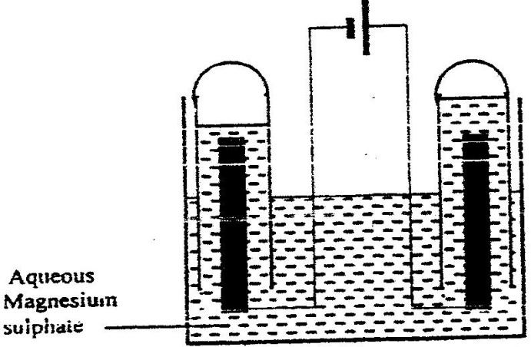
- The set-up below was used during the electrolysis of aqueous magnesium sulphate using inert electrodes.

  - On the diagram label the cathode. (½mark)
  - Write an equation for the reaction that took place at the cathode. (1 mark)

  - Explain the change that occurred to the concentration of magnesium sulphate solution during the experiment. (1½ marks)

- The equation below shows the oxidation of Sulphur (IV) oxide to Sulphur (VI) oxide in the contact process.
2SO_{2(g)} + O_{2(g )} 2SO_{3(g)} ∆H = -196kJ/mol⁻
State and explain the effect on the yield of Sulphur (IV) oxide when:
a) the temperature increased. (1½ marks)

b) the amount of oxygen is increased. (1½marks)
10. Dry carbon (II) oxide is passed over heated iron (III) oxide.
a) Name the type of reaction between carbon (II) oxide and iron (III) oxide.
(1mark)

b) Write an equation for the reaction between carbon (II) oxide and iron (III) oxide
(1mark)

c) Name a suitable drying agent for carbon (II) oxide (1mark)

11. Thermochemical equation for combustion of ethanol is shown below;
C₂H₅OH (l) + 3 O₂ (g) ———> 2 CO₂ (g) + 3 H₂O (I), AH = - 1337kJmol
(a) Determine the heating value for ethanol? (2 mark)

( C= 12, H = 1, O = 16 )

(c) Draw the structural formula for 2-methylprop-l-ene {1 mark)

12. a) Define oxidation in terms of electrons (1mark)

b) Determine the oxidation state of (1mark)
i) Suphur in SO₃ ⁻² ion

ii) Phosphorous in PO₄³⁻ ion (1mark)

13. Labels on acid solutions indicated the following:-
Acid 1 :0.1M, 6.5% ionized
Acid 2 :0. 2M, 1.3% ionized

(a) Identify the strong acid (1 mark)

(b) If 25cm³ of distilled water are added to 50cm³ of acid 2, what is its new concentration? (2 mark)

14. When 0.05 mole of magnesium were added to 100cm³ of dilute hydrochloric acid at 25°C, 25kJ of heat energy were released. The acid was in excess.
(a) Calculate the highest temperature of the reaction mixture. (2mark)
(specific heat capacity for water is 4.2J/g/ °C, density of the solution is lg/cm³)

(b) Calculate the molar heat of reaction for the reaction below (1 mark}
Mg (s) + 2HCI (aq) ———> MgCl₂ (aq) + H₂ (g)

15. Hydrogen sulphide is a highly toxic and flammable gas and is usually prepared in the fume chamber.

a) Name any two reagents that can be used to prepare hydrogen sulphide in the laboratory. (1mk)

b) Hydrogen sulphide could be used to produce sulphur as shown in the equation below:
2H₂S _{(g)} + SO2 _{(g)} 3S_{(s)} + 2H₂O _{(l)}
In the equation above, identify the reducing agent and give a reason for your answer. (1mk)

- Other than Vulcanization of rubber, identify any other uses of Sulphur. (1mk)

16. The following table shows the P^{H} values of solutions A ,B and C
Solution | A | B | C
pH | 2 | 7 | 11
- Which solution is likely to be magnesium chloride? Give a reason. (1mk)

- Identify the solution in which a sample of aluminium chloride is likely to be when dissolved in water. Explain (2mks)

- Study the information in the table below and answer the questions that follow (The letters do not represent the actual symbols of the elements)
 |  | Ionization Energy_kJ/Mole ⁻¹
Element | Electronic configuration | 1st ionization energy | 2nd ionization energy
A | 2.2 | 900 | 1800
B | 2.8.2 | 736 | 1450
C | 2.8.8.2 | 590 | 1150

- What is ionization energy (1mk)

- Explain why the 2nd ionization energy is higher than the 1st ionization energy. (1mk)

- An element K has relative atomic mass of 40.2. It has two isotopes of masses 39 and 42. Calculate the relative abundance of each isotope. (3mks)

- Use the diagram below to answer the questions that follow.
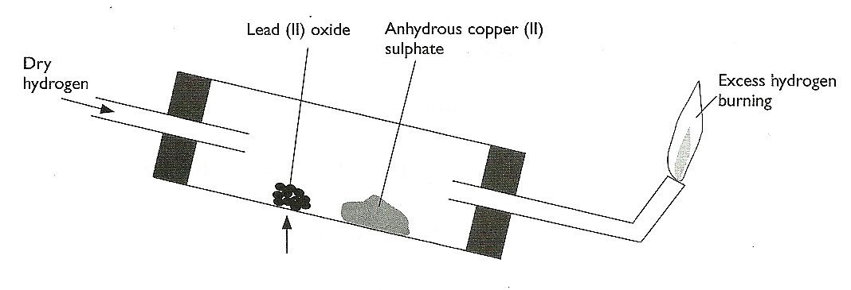
Heat
- After the experiment has been running for some time, record two major observations made in the tube. (2mks)

- Write an equation for the reaction that takes place in the dish containing lead (II) oxide. (1mk)

- a) Name two ores of iron. (1mks)

b) Give the name of the suitable method used in extracting iron from the ore. (1mk)

- Name one impurity present in pig iron and state one effect of the impurity in the physical property of iron. (1mks)

- The table below gives two samples of mixtures. Study the table and answer the questions that follow
Mixture 1 components | Mixture 2 components
Silver Chloride | Iron (III) Chloride
Lead Chloride | 1ron (III) Oxide
water | -
- State the main property that makes components of Mixture 1 separable (1mk)

- Draw a well labeled diagram of a simple laboratory set up which can be used to separate the components of Mixture 2 (2mks)

23. a) What name is given to group one elements ? (1mk)

b) Explain why there is a general increase in the atomic radii of the elements down a group
of the periodic table. (2 mks)

24. Study the flow chart below and answer the question that follows.
Excess PbO
PbO
Solution G
G
White solid
Solid
Solid J
J
Brown gas + gas K
+ Gas K
Heat strongly
1. Warm
2.Filter

2. Filter
3. Cool Filtrate

Identify: (3mks)
- Solution G

- Solid J

- Gas K

25. Draw and name structural formulae of two isomers whose molecular formula is C₄H₁₀.
(3mks)

26. The concentration of a solution of aluminium sulphate is 0.02M. How many sulphate ions are contained in 150 cm³ of the solution? (3 mks)
(Avogadro’s constant= 6.0 x 10²³)

- Explain why a solution of hydrogen chloride gas in methylbenzene does not conduct electricity but solution of the gas in water conduct electricity. (2mks)

- Nitrogen gas can be obtained from air as shown below.
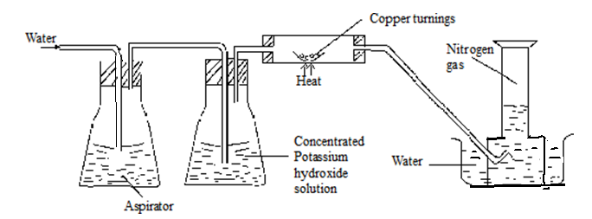

- What is the purpose of concentrated potassium hydroxide solution? (1mk)

- write the equation for the reaction that takes place in the chamber containing copper turnings (1 mk)

- The nitrogen gas obtained above is not pure. Identify one gaseous impurity in the gas.
(1mk)

29. Radioactive, polonium, 216 Po , decays as shown below:-
84
216 208
Po Pb + M α + n β
84 82
Determine the values of M and N. (2 marks)

