**CHEMISTRY PAPER 1 MARKING SCHEME**

1. A luminous flame produces more light than a non-luminous flame. Explain. (2 marks)

***Presence of unburnt (1)carbon which glow (1)***

1. The diagram below was used to electrolyze molten copper (II) chloride using graphite electrodes at s.t.p.

B

A

Heat

(a) Explain the role of heat on the above set up. **(1 mark)**

***Keep CuCl2 in molten form so as the ions are mobile to conduct electricity.***

(b) Write equations at electrode A and B. **(2mark)**

A ***Cu2+(l) + 2e → Cu(s)***

B ***2CI-(l) → Cl2(g) + 2e***

3. Dry ammonia was passed over heated copper (II) oxide in a combustion tube.

(a) State and explain the observation that was made. **(2 marks)**

***Black copper (II) oxide changed to brown - ammonia reduces copper (II) oxide to copper//***

***Colourless liquid forms on cooler parts of combustion tubes- Ammonia is oxidised***

(b) Write a balanced chemical equation for the reaction above. **(1 mark)**

${3CuO}_{(s)}+{2NH}_{3(g)}{ 3Cu}_{(s)} + {3H}_{2}O+N_{2(g)}$

4.Use dots (•) or crosses (x) to show bonding in the following molecules.

(a) Silicon chloride

CI

X •

Si

X CI

•

CI •

X

• X

CI

b) Ethanol and dimethylether have both molecular formulae $C_{2}H_{6}O.$ Explain why ethanol $C_{2}H_{6}OH$ boils at 78.20C and dimethyl ether ${CH}_{3}{OCH}_{3}$ has a boiling point -240C. (2 marks)

***Ethanol contains hydrogen bond which are strongerbonds than Van der Waal forces in dimethyl ether.***

5. When 17.2 g of hydrated calcium sulphate was heated to a constant mass, 13.6g of the residue was obtain. Find the value of n in $C_{a}{SO}_{4} nH_{2}O$. (3 marks)

(Ca = 40, S = 32, O = 16, H = 1)

|  |  |
| --- | --- |
| $${CaSO}_{4}$$ | $$H_{2}O$$ |
| ***Mass 13.6*** | ***3.6*** |
| ***R.A.M 136*** | ***18*** |
| ***No. of moles $\frac{13.6}{136}$*** | $$\frac{3.8}{18}$$ |
| ***0.1*** | ***0.2*** |
| ***Mole ratio*** |  |
| ***1*** | ***2*** |

***n = 2***

6. In an experiment, ammonium chloride was heated in a boiling tube with a moist red and blue litmus paper at the mouth of test tube. State and explain the observation made.

(3 marks)

First ***Moist red litmus changed to blue and both the moist blue litmus papers later changed to red.***

***When ammonium chloride is heated it decomposes into ammonia and hydrogen chloride gases.***

***Ammonia is light hence diffuses faster changing the litmus to blue. HCl diffuses slower changing the two litmus back to red. (W.T.T.E)***

7. Study the chart below and answer the questions that follow.

A

Rock salt

Lead (II) nitrate

White solid R

Hydrogen

chloride

KMnO4

Solid S

Iron

Gas T

(a) Name reagent used in step A. (1 mark)

***Concentrated sulphuric (VI) acid***

(b) Write the ionic equation for formation of white solid R. (1 mark)

${{Pb}^{2+}}_{(aq)}+{2Cl}^{-(aq) }{PbCl}_{2}$**(s)**

(c) Write an equation for formation of solid S. (1 mark)

${2Fe}_{(s)}+ {3Cl}_{2(g)}{ 2FeCl}_{3}$**(s)**

1. 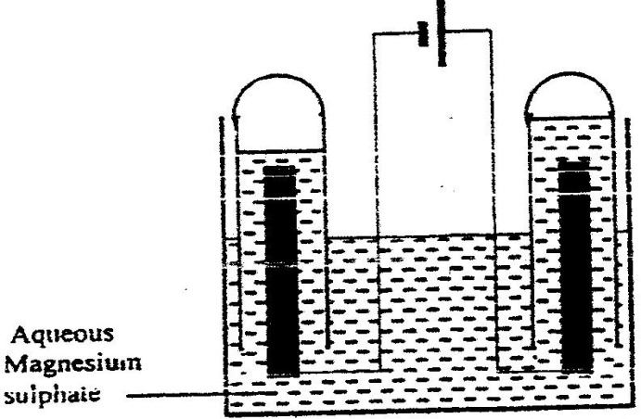The set-up below was used during the electrolysis of aqueous magnesium sulphate using inert electrodes.

Cathode 🗸1/2

* 1. On the diagram label the cathode. (½mark)
  2. Write an equation for the reaction that took place at the cathode. (1 mark)

***2H+(aq) + 2e- H2(g)*** *🗸1*

* 1. Explain the change that occurred to the concentration of magnesium sulphate solution during the experiment. (1½ marks)

***Concentration increased****🗸½* ***because the amount of water decreased****🗸½* ***as it was decomposed to hydrogen and oxygen gases which escaped****🗸½*

1. The equation below shows the oxidation of Sulphur (IV) oxide to Sulphur (VI) oxide in the contact process.

2SO2(g) + O2(g )  2SO3(g) ∆H = -196kJ/mol-

State and explain the effect on the yield of Sulphur (IV) oxide when:

a) the temperature increased. (11/2 marks)

**Yield decreases 1 backward reaction is favoured which endothermic//lower temperature 1/2**

b) the amount of oxygen is increased. **(**11**/2marks)**

**Yield increases 1 Oxygen reacts with Sulphur (IV) oxide forming more Sulphur (VI) oxide//equilibrium shifts to the right to lower concetration of oxygen.**

10.Dry carbon (II) oxide is passed over heated iron (III) oxide.

a) Name the type of reaction between carbon (II) oxide and iron (III) oxide.

(1mark)

***Redox reaction ( 1 mk)***

b) Write an equation for the reaction between carbon (II) oxide and iron (III) oxide

(1mark)

***Fe2 O3 + 3 CO2Fe (s) + 3 CO2 (g)***

***(s)***

c) Name a suitable drying agent for carbon (II) oxide (1mark)

***Concentrated sulphuric acid// anhydrous calcium chloride// calcium oxide***

11. Thermochemical equation for combustion of ethanol is shown below;  
C2H5OH (l) + 3 O2 (g) ———> 2 CO2 (g) + 3 H2O (I), AH = - 1337kJmol

(a) Determine the heating value for ethanol? (2 mark)

( C= 12, H = 1, O = 16 )

$\frac{1337kj}{46g}$***(1mark)***

***= 29.07 kJg-1 (1mark)***

(c) Draw the structural formula for 2-methylprop-l-ene {1 mark)

***H***

***H***

***C C C - H***

***H H - C – H H***

***H***

12. a) Define oxidation in terms of electrons (1mark)

***Oxidation is lose of electrons***

b) Determine the oxidation state of (1mark)

i) Suphur in SO3 -2 ion

***x +3 (-2) =- 2***

***x – 6 = -2***

***x = + 4***

ii) Phosphorous in PO43- ion (1mark)

***x + 4 ( - 2) = -3***

***x – 8 = - 3***

***x= +5***

13. Labels on acid solutions indicated the following:-

Acid 1 :0.1M, 6.5% ionized

Acid 2 :0. 2M, 1.3% ionized

(a) Identify the strong acid (1 mark)

***Acid 1***

(b) If 25cm3 of distilled water are added to 50cm3 of acid 2*,* what is its new concentration? (2 mark)

***M1V1 = M2 V2***

***M2 = M1V1 = 0.2M X 50CM3 = 0.133M***

***V2 75cm3***

14. When 0.05 mole of magnesium were added to 100cm3 of dilute hydrochloric acid at 25°C, 25kJ of heat energy were released. The acid was in excess.

(a) Calculate the highest temperature of the reaction mixture. (2mark)  
(specific heat capacity for water is 4.2J/g/ *°C,* density of the solution is lg/cm3)

***∆H = mc∆T***

***25000 J = 100g x 4.2Jg-1k-1 x ∆T***

***∆T = 25000J***

***100g x 4.2Jg-1 K-1***

***= 59. 52***

***Highest temperature reached***

***59.52 + 25***

***= 84.520C***

(b) Calculate the molar heat of reaction for the reaction below (1 mark}

Mg (s) + 2HCI (aq) ———> MgC!2 (aq) + H2 (g)

***0.05moles 25kJ***

***1 mole x***

***X = = -500kJ mol-1***

15. Hydrogen sulphide is a highly toxic and flammable gas and is usually prepared in the fume chamber.

a) Name any two reagents that can be used to prepare hydrogen sulphide in the laboratory. (1mk) ***iron(II)sulphide and dilute hydrochloric acid// any metal sulphide and an acid***

b) Hydrogen sulphide could be used to produced sulphur as shown in the equation below:

2H2S (g) + SO2 (g) 3S(s) + 2H2O(l)

In the equation above, identify the reducing agent and give a reason for your answer. (1mk)

***H2S – oxidation number of sulphur decreases from +4 to 0***

1. Other than Vulcanisation of rubber, identify any other uses of Sulphur. (1mk)

***Manufacture of sulphuric (VI)acid// any other correct use***

16. The following table shows the PH values of solutions A ,B and C

|  |  |  |  |
| --- | --- | --- | --- |
| Solution | **A** | **B** | **C** |
| pH | 2 | **7** | 11 |

1. Which solution is likely to be magnesium chloride. Give a reason. (1mk)

***B- it is neutral***

1. Identify the solution in which a sample of aluminium chloride is likely to be when dissolved in water. Explain (2mks)

***A – hydrolyses in water to produce hydrochloric acid which is a strong acid***

1. Study the information in the table below and answer the questions that follow (The letters do not represent the actual symbols of the elements)

|  |  |  |  |
| --- | --- | --- | --- |
|  | | **Ionization Energy_kJ/Mole** | |
| Element | **Electronic configuration** | **1st ionization energy** | **2nd ionization energy** |
| A | 2.2 | 900 | 1800 |
| B | 2.8.2 | 736 | 1450 |
| C | 2.8.8.2 | 590 | 1150 |

1. What is ionization energy (1mk)

***Minimum amount of energy required to remove an electrom from an atom in the gaseous state***

1. Explain why the 2nd ionization energy is higher than the 1st ionization energy. (1mk)

***Once an electron is removed from an atom, the remaining electrons are held more strongly by the net charge than the first one***

1. An element K has relative atomic mass of 40.2. It has two isotopes of masses 39 and 42. Calculate the relative abundance of each isotope. (3mks)  
   ***39 x + 42(100-x) = 40.2***

***100***

***4020 = 39x + 4200 – 42x***

***3x = 180***

***X = 60***

***K39 = 60%***

***K42 = 40%***

1. Use the diagram below to answer the questions that follow.

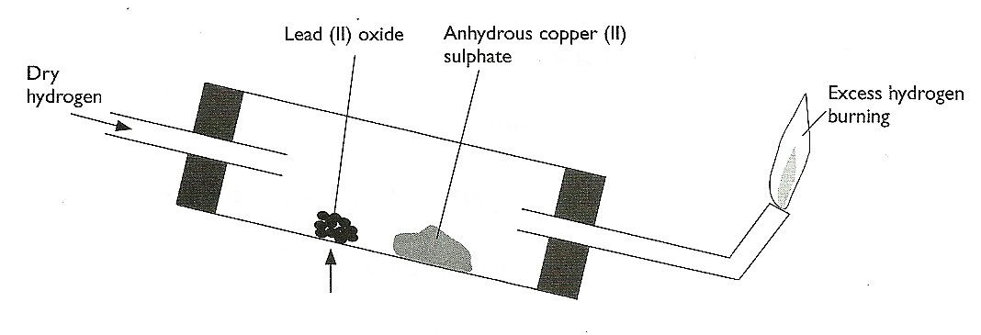

1. After the experiment has been running for some time, record two major observations made in the tube. (2mks)

***Red lead (II) oxide turns grey***

***White copper (II) sulphate turns blue***

1. Write an equation for the reaction that takes place in the dish containing lead (II) oxide. (1mk)

***PbO(s) + H2(g) Pb(s) + H2O(l)***

1. a) Name two ores of iron. (1mks)

***haematite***

***magnetite***

***siderite any two***

b) Give the name of the suitable method used in extracting iron from the ore. (1mk)

***reduction***

1. Name one impurity present in pig iron and state one effect of the impurity in the physical property of iron. (1mks)

***Carbon//silicon – makes iron brittle***

1. The table below gives two samples of mixtures. Study the table and answer the questions that follow

|  |  |
| --- | --- |
| **Mixture 1 components** | **Mixture 2 components** |
| Silver Chloride | Iron (III) Chloride |
| Lead Chloride | 1ron (III) Oxide |
| water | - |

1. State the main property that makes components of **Mixture 1** separable (1mk)

***lead(II) chloride dissolves in warm/hot water***

1. Draw a well labeled diagram of a simple laboratory set up which can be used to separate the components of **Mixture 2** (2mks)

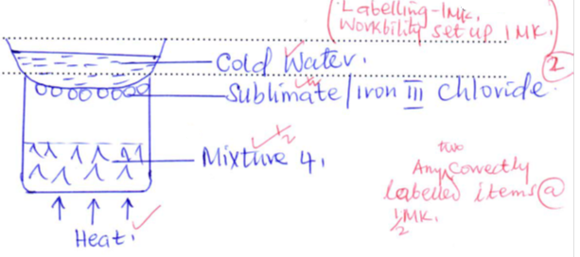

23. a) what name is given to group one elements ? (1mk)

***Alkali metals***

b) Explain why there is a general increase in the atomic radii of the elements down a group   
 of the periodic table. (2 mks)

***There is increase in number of occupied energy levels which leads to a weaker force of attraction for valence electrons***

24. Study the flow chart below and answer the question that follows.

Excess PbO

PbO

Solution G

G

White solid

Solid

Solid J

J

Brown gas + gas K

+ Gas K

Heat strongly

1. Warm

2.Filter

2. Filter

3. Cool Filtrate

Identify: (3mks)

1. Solution G

***Dilute nitric(V) acid// HNO3***

1. Solid J

***Lead(II)oxide// PbO***

1. Gas K

***Oxygen//O2***

25. Draw and name structural formulae of two isomers whose molecular formula is C4H10.   
 (3mks)



26. The concentration of a solution of aluminium sulphate is 0.02M. How many sulphate ions are contained in 150 cm3 of the solution? (3 mks)

(Avogadro’s constant= 6.0 x 1023)

***Moles of AI2(SO4)3 = 150 x 0.02***

***1000***

***= 0.003moles(1)***

***Moles of SO42- = 0.003 x 3***

***= 0.009moles(1)***

***No. of SO42- ions = 0.009 x 6.0 x 1023***

***= 5.4 x 1021 ions(1)***

1. Explain why a solution of hydrogen chloride gas in methylbenzene does not conduct electricity but solution of the gas in water conduct electricity. (2mks)

***Methylbenzene is a non- polar compound hence hydrogen chloride in it does not ionize // exist as a molecule substance but in water hydrogen chloride ionizes to give H+ and cl-  ions that’s why it conduct electricity in water.***

1. 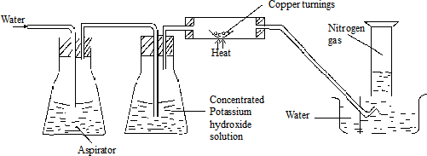Nitrogen gas can be obtained from air as shown below.
2. What is the purpose of concentrated potassium hydroxide solution? (1mk)

***Absorb carbon(IV) oxide gas.***

1. write the equation that takes place in the chamber containing copper turnings

***2Cu(s) + O2(g) 2CuO(s)*** (1 mk)

1. The nitrogen gas obtained above is not pure. Identify one gaseous impurity in the gas.

***Argon*** (1mk)

29. Radioactive, polonium, 216 Po , decays as shown below:-

84

216 208

Po Pb + M α + n β (2 marks)

84 82

Determine the values of M and N.

***M =2***

***N=2***