
A.C.K DIOCESE OF MUMIAS JOINT EVALUATION JULY 2025
ACK SCHOOLS JOINT EXAMINATION TERM 2 2025
121/2
MATHEMATICS PAPER 2
JULY 2025
TIME: 2½ HOURS
NAME………………………………………………… SCHOOL: ……………………
INDEX NO: ……….………… CLASS: …….…… ADM NO……………….
Kenya Certificate of Secondary Education Mathematics
Paper 2 2½ Hours.

INSTRUCTIONS TO CANDIDATES

- Write your name, index number and Admission number in the spaces provided at the top of this page.
- Sign and write the date of examination in the spaces provided above

- This paper consists of two sections: Section I and Section II.
- Answer ALL questions in Section 1 and ONLY FIVE questions from section II
- All answers and workings must be written on the question paper in the spaces provided below each question.
- Show all the steps in your calculation, giving your answer at each stage in the spaces below each question.
- Marks may be given for correct working even if the answer is wrong.
- Non – Programmable silent electronic calculators and KNEC mathematical tables may be used, except where stated otherwise.
- This paper consists of 14 printed pages.
- Candidates should check the question paper to ascertain that all the pages are printed as indicated and that no questions are missing.
- Candidates should answer the questions in English.
For Examiner’s Use Only
Section I
1 | 2 | 3 | 4 | 5 | 6 | 7 | 8 | 9 | 10 | 11 | 12 | 13 | 14 | 15 | 16 | Total

Section II
17 | 18 | 19 | 20 | 21 | 22 | 23 | 24 | Total

Grand Total
SECTION I: (50MARKS)
(Answer all the 16 question in this section)

- If $\frac{1}{3 - \sqrt{5}}-\frac{2 + 2\sqrt{5}}{3 + \sqrt{5}}=a+b\sqrt{c}$ find the value of a, b and c. (3mks)

- Solve the following quadratic equation using the method of completing the square (3mks)
$2x^{2}-6x+4=0$

- Find the matrix B such that AB = 1 and $A= \left(\begin{matrix}3 & 2 \\ -1 & 3\end{matrix}\right)$ hence find the point of intersection of the lines 3x + 2y = 10 and 3y – 4 = x. (4mks)

- Solve for x in the equation (3mks)
½ log2 81 + log2(x² – ^{X}/₃) = 1

- A new infinix smartphone depreciates at 8% per annum in the first year and 10% per year in the second year. If its value at the end of the second year was sh. 44, 440. Calculate its original value. (3marks)

- Given that $X= \sqrt[3]{\frac{tP}{2u+P}}$ make P the subject of the formula (3mks)

- A circle centre (2,3) passes through a midpoint of the line PQ. If (3, 4) and (6, 1) are the coordinates of P and Q respectively. Find the equation of the circle in the form ax² + by² + cx + dy + e = 0 where a, b, c, d and e are constants (3mks)

- A closed cylindrical metal tin is to have a capacity of 250ml. If the area of the metal used is to be a minimum, calculate the radius of the tin.
(3mks)

- Solve for x if ${2\sin\left(x- \frac{π}{6}\right)}^{∁}= \sqrt{3 } for 0 ≤x ≤2π^{∁}$ (3mks)
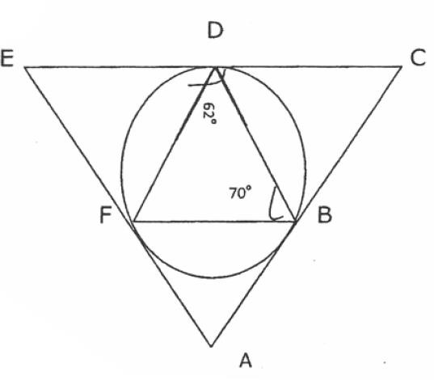
- In the figure below AC, CE, and EA are tangents to the circle. Find

  - Angle EAC (1mk)

  - Angle CEA (1mk)

  - Angle ACE (1mk)

- The base and height of a right-angle triangle were measured as 8.4cm and 6.5cm respectively. Find to 3 significant figures the maximum percentage error in calculating the area of the triangle. (3mks)

- A triangle ABC is such that AB = 5cm, BC = 6cm and AC = 7cm.
  - Calculate the size of angle ACB correct to 2 decimal places
(2mks)

  - A perpendicular drawn from A meets BC at N. Calculate the length AN correct to one decimal place. (2mks)

- a) Expand (3 – ½x)5 up to the fourth term (1mks)

b) Hence use your expansion in (a) above to evaluate (3.25)⁵ correct to four significant figures. (2mks)

- A quantity V is partly constant and partly varies inversely as the square of
W. If W = 2, when V = 14 and W = 3, when V = 9, write an equation connecting V and W. Hence find V when W = 6. (3mks)

- Two machines A and B working together can finish a job in 6 days. After working together for 2 days, machine A breaks down and takes machine B a further 10 days to finish the job by itself. How long would it take machine A, to finish the whole job by itself assuming it did not breakdown
(3mks)

- The points A, B and C lie on a straight line. The position vectors of A and C are 2i + 3j + 9k and 5i – 3j + ck respectively. B divides AC internally in the ratio 2:1. Find the magnitude of B from the origin (3mks)

SECTION II: (50 MARKS)
Answer ANY FIVE questions in the spaces provided

- Mr. Kimwele’s basic salary in June was Ksh. 17,000. He was also paid a house allowance of Kshs. 6,000 a commuter allowance of Kshs. 2,500 and a medical allowance of Kshs. 1,800. In July of that year, Mr. Kimwele’s basic salary was raised by 2%.
  - Calculate Mr. Kimwele’s
    - Basic pay for July (2mks)

    - Total taxable income in July of that year (2mks)

  - In that year, the income tax rates were as shown in the table below
Taxable Income (Kshs.) | Percentage rate of tax per shillings
Up to 9680 | 10
From 9681 – 18800 | 15
From 18801 – 27920 | 20
From 27921 – 37040 | 25
From 37041 and above | 30

Given that the monthly personal relief was Kshs. 1056. Calculate the net tax paid by Mr. Kimwele for July (6mks)

- In science class ²/3 of the class are boys and the rest are girls. 80% of the boys and 90% of the girls are right-handed. The probability that a right-handed student will break a test tube in any session of an experiment is ¹/10 and the corresponding probability for the left-handed student is ³/10. These probabilities being independent of the student’s sex.
  - Use a tree diagram to represent this information. (2mks)

  - Find the probability that
    - A student chosen from the class is left-handed (2mks)

    - A test tube is broken by a left-handed student (2mks)

    - A test tube is broken by a right-handed student (2mks)

    - A test tube is broken in any session of the experiment. (2mks)

- The second, third and fourteenth terms of an arithmetic progression are the three consecutive terms of a geometric progression. The 10th term of the arithmetic progression is 18. Find
  - The first term and common difference of the arithmetic progression.
(4mks)

  - The sum of the first 10 terms of the arithmetic progression.
(3mks)

  - The sixth term of the geometric progression (3mks)

- The marks scored by 40 students in mathematics test were as shown in the table below
Marks | 48 – 52 | 53 – 57 | 58 – 62 | 63 – 67 | 68 – 72 | 73 – 77
No. of  students | 3 | 4 | 10 | 12 | 8 | 3
  - Using an assumed mean of 64, calculate the mean mark (3mks)

  - Calculate the standard deviation of the data (4mks)

  - By calculation, find the semi-interquartile range (3mks)

- A transformation represented by the matrix $\left(\begin{matrix}1 & -2 \\ 2 & -1\end{matrix}\right)$ maps ABC with A(1, 3), B(5, 3) and C(5, 7) onto AʹBʹCʹ .
  - On the grid provided, draw triangle ABC and its image triangle AʹBʹCʹ. (3mks)


  - Find the areas of triangle ABC and AʹBʹCʹ (2mks

  - P represents a negative quarter turn about the origin and maps triangle AʹBʹCʹ onto triangle AʹʹBʹʹCʹʹ. Draw triangle AʹʹBʹʹCʹʹ on the same grid (2mks)

  - Determine the matrix of a single transformation which maps ABC onto AʹʹBʹʹCʹʹ (1mk)

  - AʹʹBʹʹCʹʹ is then translated by $T= \left({-3 \atop -6}\right)$ to obtain AʹʹʹBʹʹʹCʹʹʹ. Determine the coordinates of the new triangle and plot it on the same grid
(2mks)

- The variables P and Q are connected by the law $PQ^{2}=a+bP$, where a and b are constants.
The table below gives values of P and Q
P | 0.5 | 1.0 | 1.5 | 2.0 | 2.5 | 3.0 | 3.5
Q | 5.39 | 4.12 | 3.61 | 3.32 | 3.13 | 3.00 | 2.90
By drawing a suitable graph determine;



  - The value of a and b and the law connecting P and Q. (8mks)

  - The value of P when Q = 14.2 (to 3 significant figures) (1mk)

  - The value of Q when P = 46 (to 3 significant figures) (1mk)

- A tailor makes two types of garments A and B. Garment A requires 3m of material while B requires 2 ½ m of material. The tailor uses not more than 600m of material daily in making both garments. The tailor must make not more than 100 garments of type A and not less than 80 of type B each day.
  - Write down four inequalities from this information.

  - Draw a graph for the inequalities shading the unwanted regions

  - If the tailor makes a profit of sh. 80 on garment A and a profit of sh. 60 on garment B, how many garments must she make in order to maximize her total profit if all the garments are sold at once.

- The figure below shows a cuboid ABCDEFGH with a square base. The points L, M and N are on the midpoints of EH, AD and BC respectively. AC
= 7.5cm and CF = 10cm
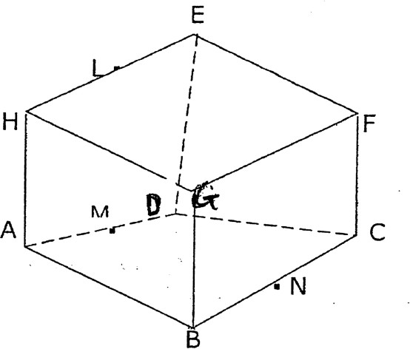

Calculate to one decimal place
  - The length BC (2mks)

  - The length LN (2mks)

  - The size of the angle between the plane EHBC and the horizontal plane ABCD. (3mks)
  - Angle between AF and ABCD

