NAME ………………………………………… INDEX NO …….…………………..
SCHOOL ………………………………………… SIGNATURE …………..……....…….
DATE ……………….………..
231/2
BIOLOGY
PAPER 2
(THEORY)
2 HOURS

INTER – SECONDARY SCHOOLS EXAMINATIONS
FORM 3 END OF YEAR EXAMINATION 2025

Kenya Certificate of Secondary Education (K.C.S.E)

TO CANDIDATES
- Write your name and Index Number in the spaces provided above.
- This paper consists of two sections. Section A and section B.
- Answer ALL questions in section A in the spaces provided. In section B answer question 6 (compulsory) and either question 7 or 8 in the spaces provided after question 8
- This paper consists of 11 Printed pages. Candidates should check the question paper to ensure that all the papers are printed as indicated and no questions are missing For Examiners use only.
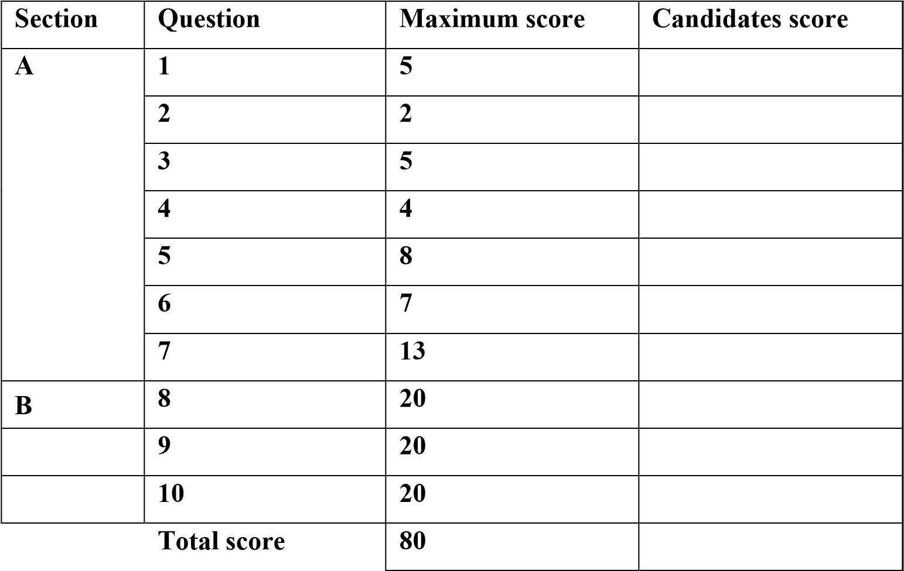

© 2022, inter – secondary schools examination
231/2
Biology

Paper 2 (Theory)

SECTION A
1. To what kingdoms do the following organisms belong  Organism Kingdom |  | (5 Marks)
- Bacteria ________________________________
- Amoeba ________________________________
- Mango ________________________________
- Yeast ________________________________
(e) Bee ________________________________
2. Name the part of a light microscope that
(a) Holds the eye piece and revolving nose piece |  | (1 Mark)
…………………………………………………………………………………………………………
(b) Concentrates light on the object on stage (1 Mark)
…………………………………………………………………………………………………………
- Two red blood cells X and Y were dipped in two solutions and the results were as shown below.
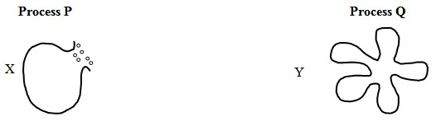
  - In what type of solution were the cells placed (2 Marks)
Cell X
…………………………………………………………………………………………………………
Cell Y
…………………………………………………………………………………………………………
  - Identify process (2 Marks)
    - P……………………………………………………………………………………………………
    - Q………………………………………………….…………………………………………………
  - How can process Q be reversed? (1 Mark)
…………………………………………………………………………………………………………
…………………………………………………………………………………………………………
…………………………………………………………………………………………………………
…………………………………………………………………………………………………………

|

- The diagram below represents a plant in the division Bryophyta.
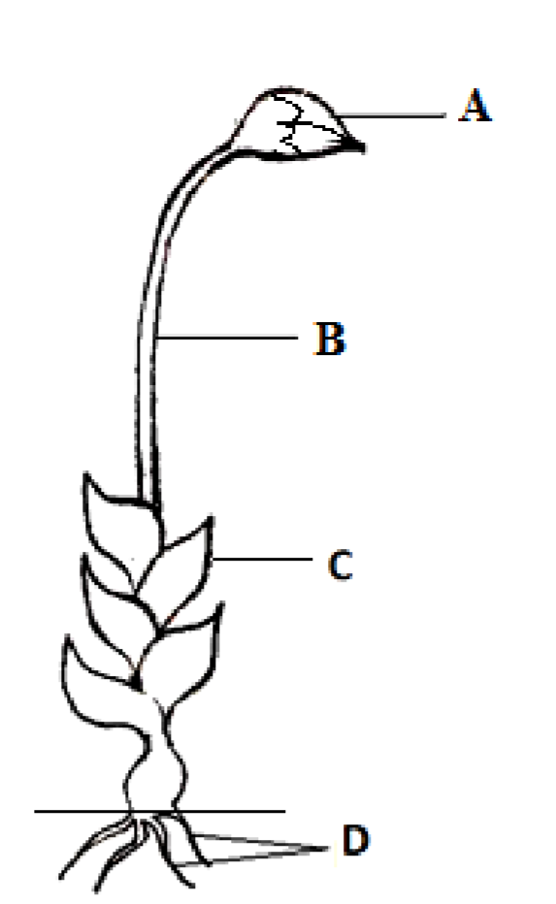
(i) Name the parts labelled B and D (2 Marks)
B……………………………………………………………………………………………………….
C ………………………………………………………………………………………………………
(ii) State one function for each of the parts labelled A & C
A ………………………………………………………………………………………………………
C ………………………………………………………………………………………………………
- (a) Explain the importance of the following in photosynthesis (3 Marks)
  - Light
……………………………………….…………………………………………………………………
…………………………………………………………………………………………………………
  - Carbon (IV) Oxide
…………………………………………………………………………………………………………
…………………………………………………………………………………………………………
  - Chlorophyll
…………………………………………………………………………………………………………
…………………………………………………………………………………………………………
(b) Name one appropriate food substance for each of the following enzymes (2 Marks)
    - Ptyalin………………………………………………………………………………………………
    - Pepsin ………………………………………………………………………………………………
(c) State the cause and two symptoms of Beriberi
Cause ………………………………………………………………………………………… (1 Mark)
Symptoms (2 Marks)
    - ………………………………………………………………………………………………………
    - ………………………………………………………………………………………………………

- A set up that was used to investigate a certain process in plants is shown in the diagram below.
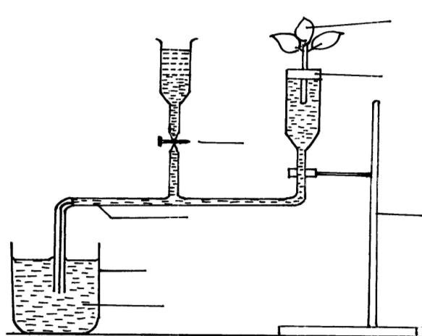

Rubber bung

Retort stand

Tap

Leaf
y

shoot

Capillary
tubing

Beaker

Water

Ruler

  - What process was being investigated (1 Mark)
…………………………………………………………………………………………………………
  - (i) State two precautions that should be taken when setting up the experiment. (2 Marks)
…………………………………………………………………………………………………………
…………………………………………………………………………………………………………
………………………………………………………………………………………………………….
(ii) Give a reason for each precaution stated in b (i) above (2 Marks)
…………………………………………………………………………………………………………
…………………………………………………………………………………………………………
…………………………………………………………………………………………………………
  - State three environmental factors that influence the process under investigation (3 Marks)
…………………………………………………………………………………………………………
…………………………………………………………………………………………………………
…………………………………………………………………………………………………………
- After an ecological study of feeding relationship students constructed the food web below.

|
e
HighSchool.co.k

Large bird

Bird Y

Bird K

Bird L

Bird M

Bird N

Small fish

Zoo plankton

Snails

Green plant
s

Al
ga
e

Mussels

  - Name the process through which energy from the sun is incorporated into the products. (1 Mark)
…………………………………………………………………………………………………………
…………………………………………………………………………………………………………
  - State the mode of feeding of the birds in the food web. (1 Mark)
…………………………………………………………………………………………………………
…………………………………………………………………………………………………………
  - Name two ecosystems in which the organisms in the food web live (2 Marks)
…………………………………………………………………………………………………………
…………………………………………………………………………………………………………
…………………………………………………………………………………………………………
  - From the information in the food web, construct food chain with the large bird as a quaternary
consumer (1 Mark)
…………………………………………………………………………………………………………
…………………………………………………………………………………………………………
…………………………………………………………………………………………………………
…………………………………………………………………………………………………………
…………………………………………………………………………………………………………
  - What would happen to the organisms in the food web if bird N migrated? (3 Marks)
…………………………………………………………………………………………………………
…………………………………………………………………………………………………………
…………………………………………………………………………………………………………
…………………………………………………………………………………………………………
  - Not all the energy from one trophic level is available to the next level. Explain (3 Marks)
…………………………………………………………………………………………………………
…………………………………………………………………………………………………………
…………………………………………………………………………………………………………
  - Name two organisms which play a role in the ecosystem not included in the food web (2 Marks)
…………………………………………………………………………………………………………
…………………………………………………………………………………………………………
…………………………………………………………………………………………………………

Answer question 8 (Compulsory) in the spaces provided and either 9 or 10 in the spaces provided after question 10.
- An experiment was carried out to investigate the effects of hormones on growth of lateral buds of three pea plants.
The shoots were treated as follows:-
Shoot A – Apical bud was removed
Shoot B – Apical bud was removed and gibberellic acid placed on the cut shoot.
Shoot C – Apical bud was left intact.
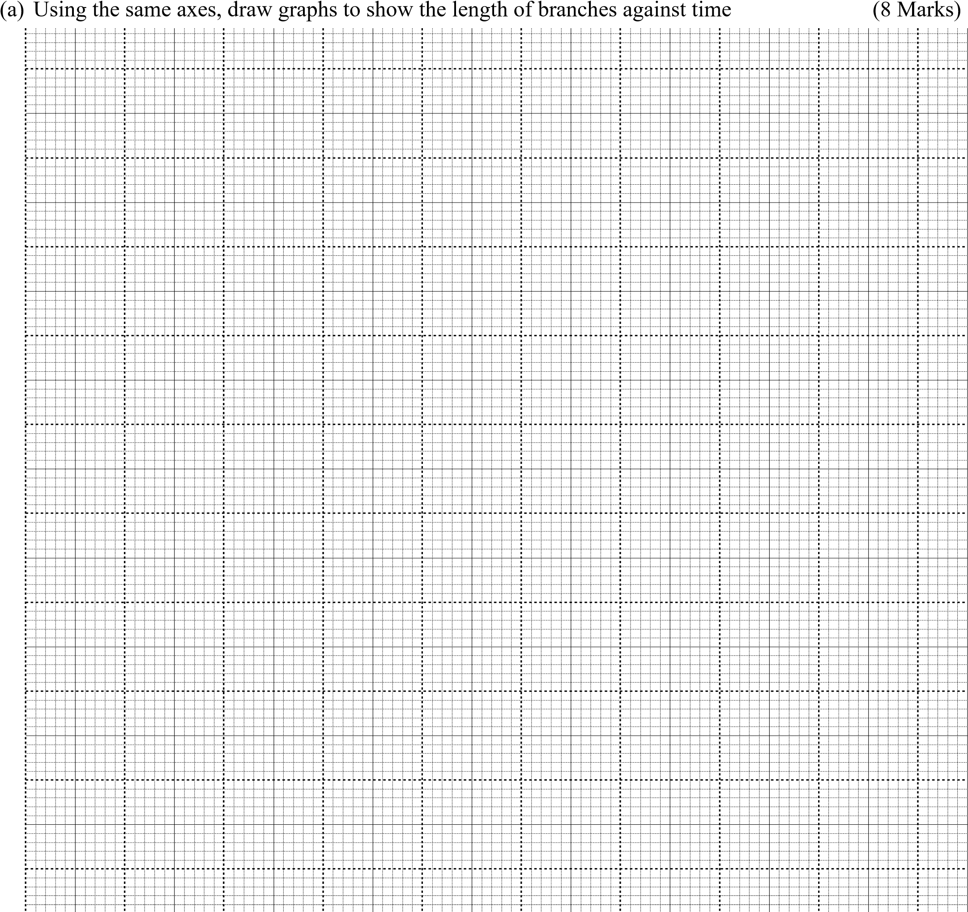
The lengths of the branches developing from the lateral buds were determined at regular intervals.
The results obtained are shown in the table below.
Time in days | Length of branches in millimeters
 | Shoot A | Shoot B | Shoot C
0 | 3 | 3 | 3
2 | 10 | 12 | 3
4 | 28 | 48 | 8
6 | 50 | 90 | 14
8 | 80 | 120 | 20
10 | 118 | 152 | 26

- (i) What was the length of the branch in shoot B on the 7th day? (1 Mark)
…………………………………………………………………………………………………………
…………………………………………………………………………………………………………
(ii) What would be the expected length of the branch developing from shoot A on the 11th day
(1 Mark)
…………………………………………………………………………………………………………
…………………………………………………………………………………………………………
- Account for the results obtained in the experiment. (6 Marks)
…………………………………………………………………………………………………………
…………………………………………………………………………………………………………
…………………………………………………………………………………………………………
…………………………………………………………………………………………………………
…………………………………………………………………………………………………………
…………………………………………………………………………………………………………
…………………………………………………………………………………………………………
…………………………………………………………………………………………………………
…………………………………………………………………………………………………………
…………………………………………………………………………………………………………
…………………………………………………………………………………………………………
…………………………………………………………………………………………………………
- Why was shoot C included in the experiment?
…………………………………………………………………………………………………………
…………………………………………………………………………………………………………
- What is the importance of gibberellic acid in Agriculture (1 Mark)
…………………………………………………………………………………………………………
…………………………………………………………………………………………………………
…………………………………………………………………………………………………………
- State two physiological processes that are brought about by the application of gibberellic acid on plants. (2 Marks)
…………………………………………………………………………………………………………
…………………………………………………………………………………………………………
…………………………………………………………………………………………………………
…………………………………………………………………………………………………………
………………………………………………………………………………………………………… …………………………………………………………………………………………………………

- (a) Describe the process of blood clotting in human beings. (10 Marks)
  - How are respiratory surfaces in mammals adapted to their functions (10 Marks)
- (a) Describe the composition of glomerular filtrate passing out into the Bowman’s capsule and explain how it is formed (8 Marks)
  - How does the body act to conserve water content and also reduce its osmotic pressure when water
intake is low? (12 Marks)
………………………………………………………………………………………………………………
………………………………………………………………………………………………………………
………………………………………………………………………………………………………………
………………………………………………………………………………………………………………
………………………………………………………………………………………………………………
………………………………………………………………………………………………………………
………………………………………………………………………………………………………………
………………………………………………………………………………………………………………
………………………………………………………………………………………………………………
………………………………………………………………………………………………………………
………………………………………………………………………………………………………………
………………………………………………………………………………………………………………
………………………………………………………………………………………………………………
………………………………………………………………………………………………………………
………………………………………………………………………………………………………………
………………………………………………………………………………………………………………
………………………………………………………………………………………………………………
………………………………………………………………………………………………………………
………………………………………………………………………………………………………………
………………………………………………………………………………………………………………
………………………………………………………………………………………………………………
………………………………………………………………………………………………………………
………………………………………………………………………………………………………………
………………………………………………………………………………………………………………
………………………………………………………………………………………………………………
………………………………………………………………………………………………………………
……………………………………………………………………………………………………………… ……………………………………………………………………………………………………………… ………………………………………………………………………………………………………………
………………………………………………………………………………………………………………
………………………………………………………………………………………………………………
………………………………………………………………………………………………………………
……………………………………………………………………………………………………………… ………………………………………………………………………………………………………………
………………………………………………………………………………………………………………
………………………………………………………………………………………………………………
………………………………………………………………………………………………………………
………………………………………………………………………………………………………………
………………………………………………………………………………………………………………
………………………………………………………………………………………………………………
………………………………………………………………………………………………………………
………………………………………………………………………………………………………………
………………………………………………………………………………………………………………
………………………………………………………………………………………………………………
………………………………………………………………………………………………………………
………………………………………………………………………………………………………………
………………………………………………………………………………………………………………
………………………………………………………………………………………………………………
………………………………………………………………………………………………………………
………………………………………………………………………………………………………………
………………………………………………………………………………………………………………
………………………………………………………………………………………………………………
………………………………………………………………………………………………………………
………………………………………………………………………………………………………………
………………………………………………………………………………………………………………
………………………………………………………………………………………………………………
………………………………………………………………………………………………………………
………………………………………………………………………………………………………………
………………………………………………………………………………………………………………
………………………………………………………………………………………………………………
……………………………………………………………………………………………………………… ………………………………………………………………………………………………………………

………………………………………………………………………………………………………………
………………………………………………………………………………………………………………
………………………………………………………………………………………………………………
………………………………………………………………………………………………………………
………………………………………………………………………………………………………………
………………………………………………………………………………………………………………
………………………………………………………………………………………………………………
………………………………………………………………………………………………………………
………………………………………………………………………………………………………………
………………………………………………………………………………………………………………
………………………………………………………………………………………………………………
………………………………………………………………………………………………………………
………………………………………………………………………………………………………………
………………………………………………………………………………………………………………
………………………………………………………………………………………………………………
………………………………………………………………………………………………………………
………………………………………………………………………………………………………………
………………………………………………………………………………………………………………
………………………………………………………………………………………………………………
………………………………………………………………………………………………………………
………………………………………………………………………………………………………………
………………………………………………………………………………………………………………
………………………………………………………………………………………………………………
………………………………………………………………………………………………………………
………………………………………………………………………………………………………………
………………………………………………………………………………………………………………
………………………………………………………………………………………………………………
………………………………………………………………………………………………………………
………………………………………………………………………………………………………………
………………………………………………………………………………………………………………
………………………………………………………………………………………………………………
………………………………………………………………………………………………………………
……………………………………………………………………………………………………………… ……………………………………………………………………………………………………………… ……………………………………………………………………………………………………………… ………………………………………………………………………………………………………………
………………………………………………………………………………………………………………
………………………………………………………………………………………………………………
………………………………………………………………………………………………………………
………………………………………………………………………………………………………………
………………………………………………………………………………………………………………
………………………………………………………………………………………………………………
………………………………………………………………………………………………………………
………………………………………………………………………………………………………………
………………………………………………………………………………………………………………
………………………………………………………………………………………………………………
………………………………………………………………………………………………………………
………………………………………………………………………………………………………………
………………………………………………………………………………………………………………
………………………………………………………………………………………………………………
………………………………………………………………………………………………………………
………………………………………………………………………………………………………………
………………………………………………………………………………………………………………
………………………………………………………………………………………………………………
………………………………………………………………………………………………………………
………………………………………………………………………………………………………………
………………………………………………………………………………………………………………
………………………………………………………………………………………………………………
………………………………………………………………………………………………………………
………………………………………………………………………………………………………………
………………………………………………………………………………………………………………
………………………………………………………………………………………………………………
……………………………………………………………………………………………………………… ………………………………………………………………………………………………………………
………………………………………………………………………………………………………………
……………………………………………………………………………………………………………… ……………………………………………………………………………………………………………… ………………………………………………………………………………………………………………
………………………………………………………………………………………………………………
………………………………………………………………………………………………………………

