BIOLOGY PAPER 231/2
MARKING SCHEME
- (a) Kingdom Monera (5 Marks)
  - Kingdom Protoctista (Prorista)
  - Kingdom Plantae Rej. Plants
  - Kingdom Fungi
  - Kingdom Animalia
- (a) Tube (2 Marks)
  - Condenser (diaphragm)
- (a) X – Hypotonic solution (2 Marks)
Y – Hypertonic solution (b) Process P Haemolysis
Q Crenation
(c) Placing the cell in hypotonic solution/placing the cell in a solution which has less concentration of solute than the cell.
- (i) B – Seta (2 Marks)
D – Rhizoid
(ii) A – Asexual reproduction/spore formation/Sporulation (2 Marks)
C – Photosynthesis
- (a) (i) Light – Driving energy for the process of photosynthesis. (3 Marks) (ii) Raw material/combines with Hydrogen to form simple sugars
  - (i) Ptyalin – Starch (2 Marks)
    - Pepsin – Proteins
  - Cause – Lack of vitamin B₁ (1 Mark)
Symptoms: General weakness, retarded growth in children. (2Marks)
Muscle wasting, swelling of feet and legs
- (a) Transpiration/Rate of transpiration (1 Mark)
  - (i) – Cut shoot under water; (2 Marks)
- Apply petroleum jelly to bung glass/Bung shoot connection;
    - - To ensure no air enters leafy shoot/xylem; (2 Marks)
      - To ensure the apparatus is air tight.
      - To remove air bubbles from tubes;
  - – Temperature;
    - Wind;
    - Humidity
    - Light intensity;
    - Atmospheric pressure/Air pressure; Any 3 (3 Marks)
- (a) Photosynthesis; 1 Mark
  - Carnivorous; (Rej carnivores) 1 Mark
  - Aquatic (All marine rej. Fresh water) (2 Marks)
  - Algae →Zoo planktons → Small fish →Bird J →Large bird
  - - More/Increase of snails (for bird M);
    - Rise in population of bird M
    - Green plants reduce; as they are eaten by more snails;
    - Population of large birds may remain constant increase or reduce
  - (i) Energy lost through respiration; accept in form of heat (3 Marks)
    - Egestion/defaecation/When passing out faeces;
    - Excretion/When urinating/sweating/breathing out;
  - Bacteria; Fungi; (Rej decomposers and saprophytes/moulds unless correct examples are given)
(2 Marks)
- (b) (i) 105 1; (mm) (1Mark)
(ii) 140mm (Acc 134 – 140;(mm) (1 Mark)
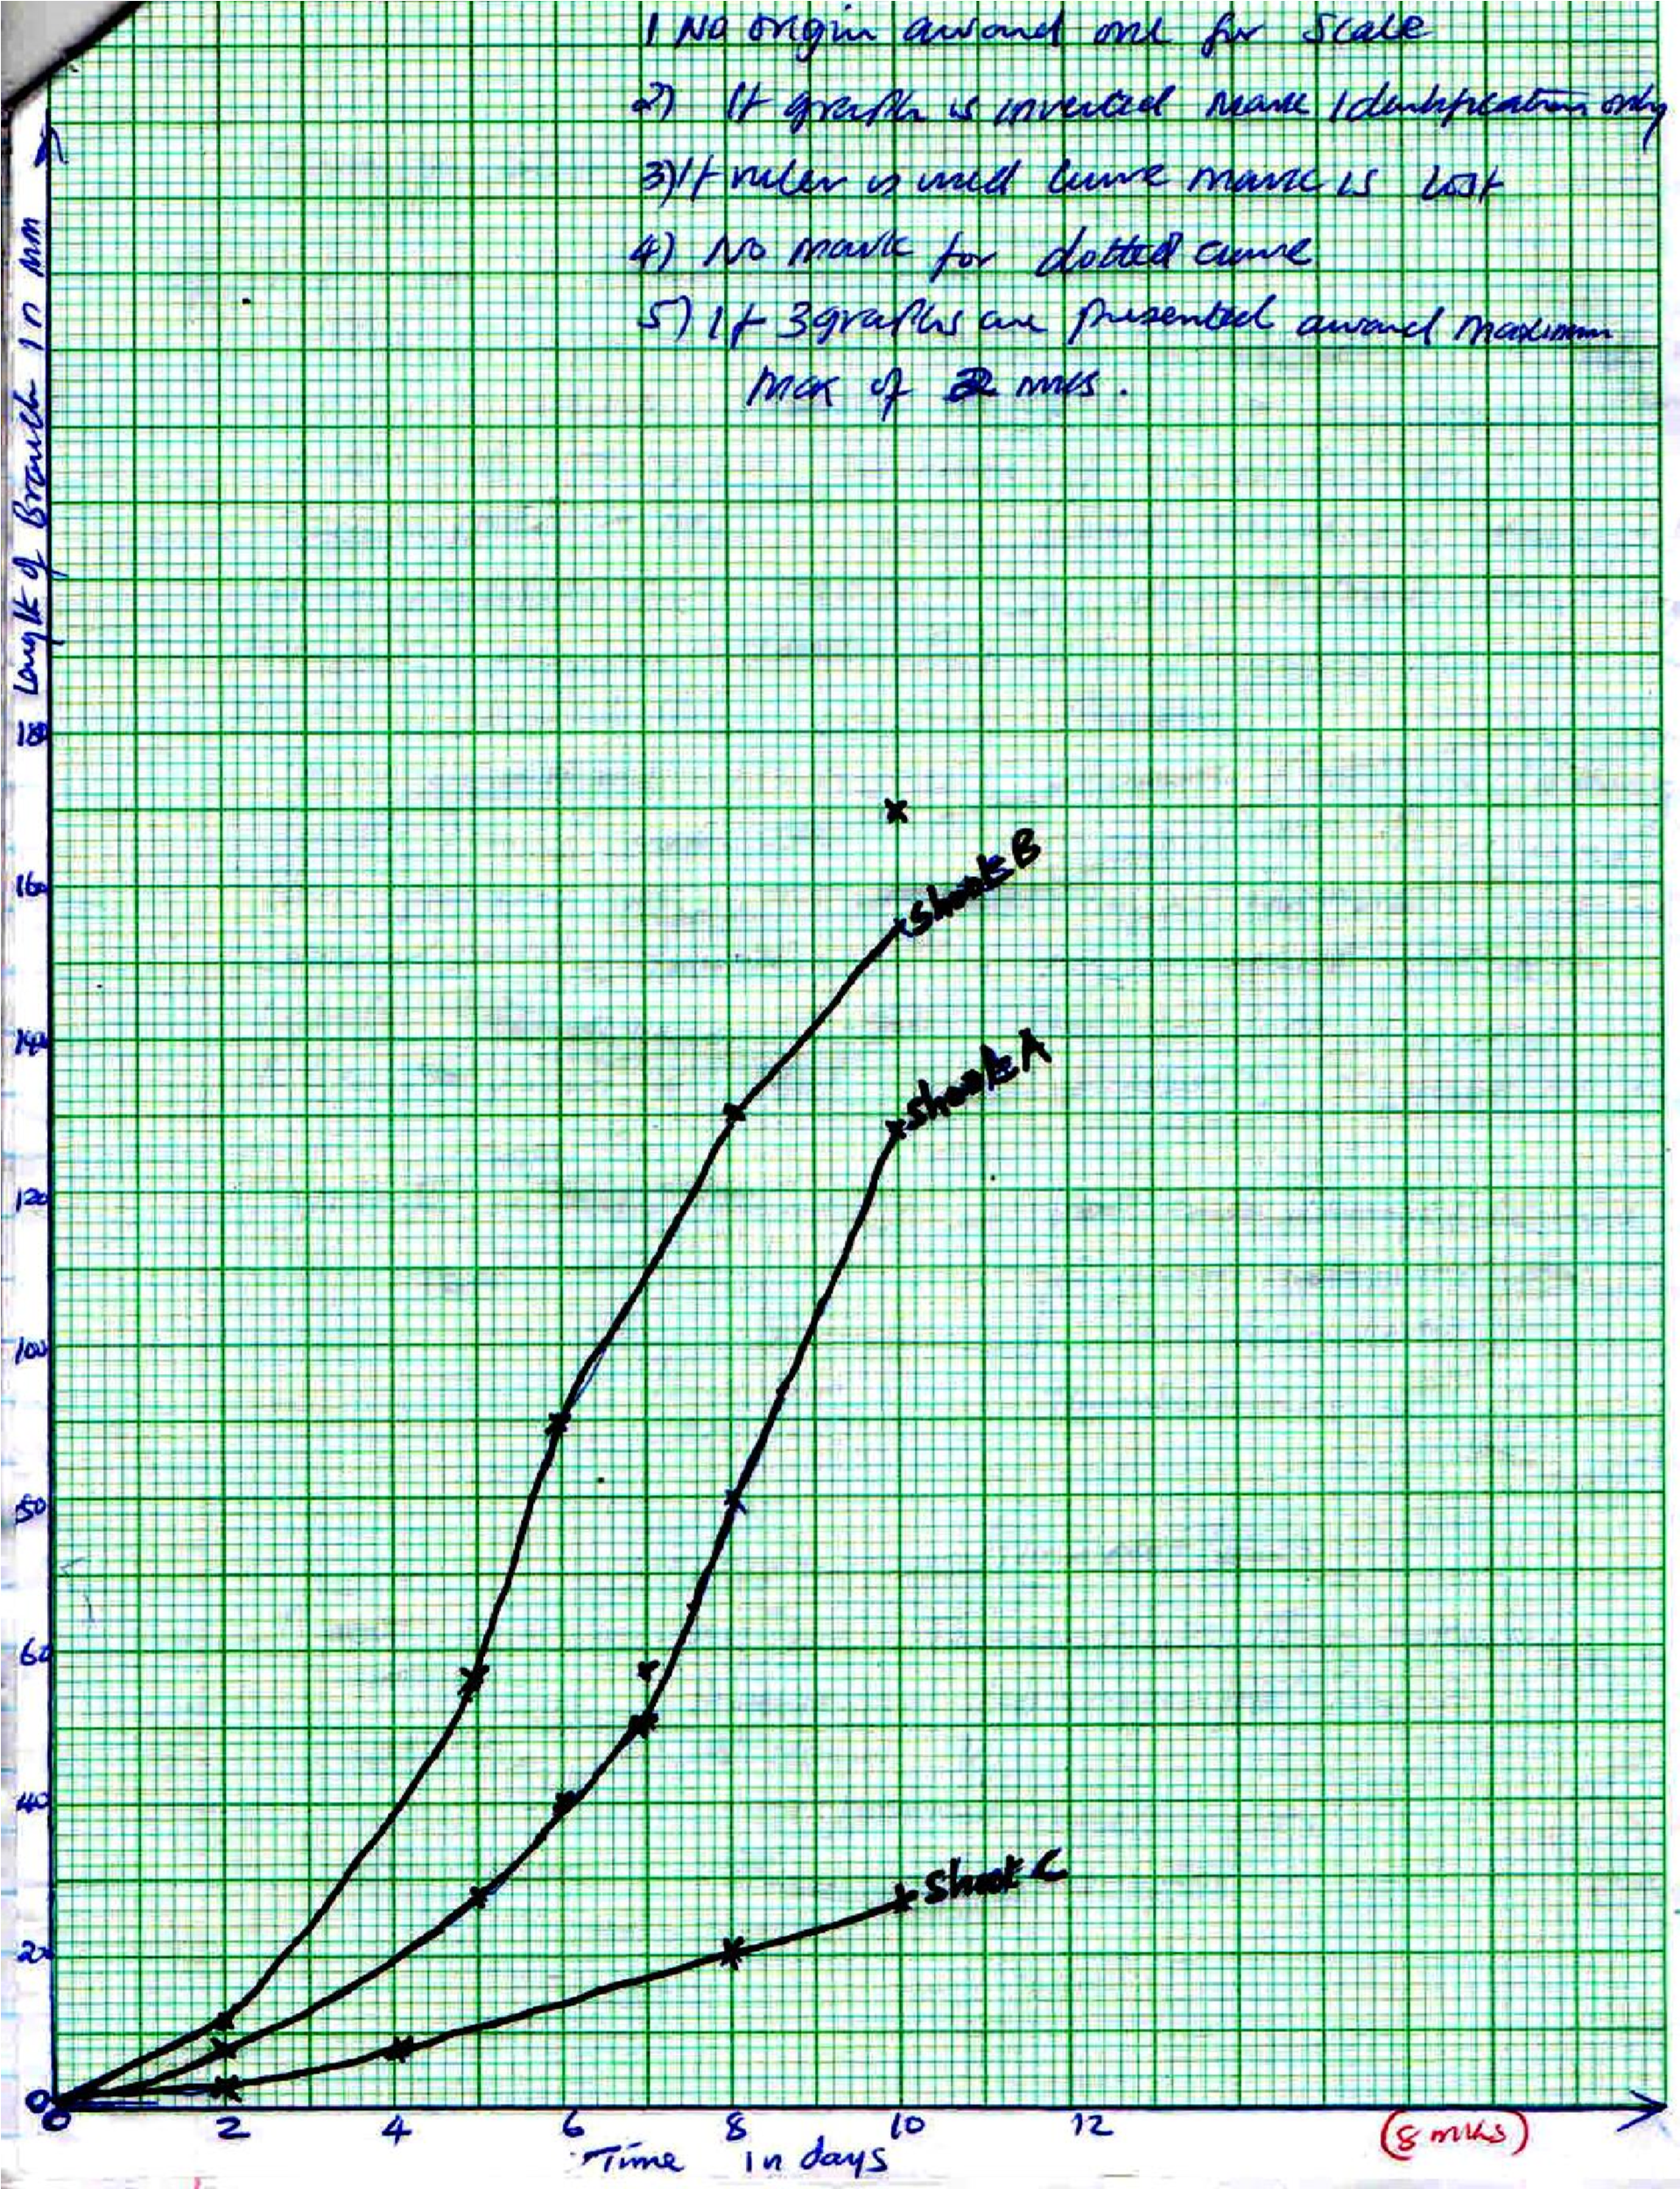

  - The tip of the shoot which was removed contained (IAA accept Auxin; which (IAA) causes Apical Dominance/inhibits growth/Development of more lateral buds; hence lateral buds sprouted/grew; (Accept Branches for buds)
Graph B
The gibberellic acid (which was added on the cut); Promotes formation/growth of internal branches on the stem); hence the fast growth of branches of shoot B;
Graph C. The shoot tip which remained intact contains IAA(all auxin) which inhibits growth /development of lateral buds; hence little change/little growth of lateral branches.
Any two points (6 Marks)
  - Control; (1 Mark)
  - Increases productivity/yields; (1 Mark)
  - Promote cell division; (2Marks)

- (a) Process of blood clotting;
The process of clotting involves a series of complex reactions where soluble protein is converted into a mass of tangled threads of insoluble protein;
This process begins when blood vessels are damaged; When platelets are exposed to a rapture on damaged tissues to release thromboplastin (enzyme Thrombokinase) which initiates the clotting process; Thrombokinase neutralizes heparin (an anti-clotting factor) and activates Prothrombin to thrombin; This process requires calcium ions. Thrombin activates conversion of fibrinogen to fibrin which forms a mesh of fibres on the cut surface to trap RBC to form a clot. The process requires vit. K.
Vit. K Prothrombin Platelets or damaged tissue

 | Thrombin (Enzyme) | Thromboplastin
Various factors including ant Ca2+ haemophilia

Fibrinogen Fibrin clot (tissues)
Process involves enzyme – Thromboplastin (Thrombokinase)
Proteins – Fibrinogen (Prothrombin)
Vitamin K
Ions/mineral – Calcium ions
Cells – Thrombocytes (10 Marks)

(b) Respiratory surfaces in mammals include the alveoli which are basic units of lungs; The alveoli have the following adaptation for gaseous exchange.
Moist
Moisture film is important as it helps respiratory gases to be dissolved/or as they are transpired in solution form. Thin wall
Have a single layer of cells. This reduces distance across which respiratory gases are transported through or diffuse through. Large surface area
This is improve by being folded + numerous. This gives enough surface for exchange of respiratory gases.

Vascularised
This helps respiratory gases easily reach the blood stream in order to be transported easily to cells for respiration. Ventilated
This ensures that stale air is removed and fresh air joins the respiratory. (10 Marks)
10. (a) Glomerular filtrate is composed of water, mineral salts, glucose, amino acids, urea, hormones, fibrinogen;
The lumen of the different arterial is wider than that of the efferent arteriole; more blood enters the glomerular capillaries than it leaves; a high pressure is set up causing ultra filtration to occur; very small molecules pass through the walls and larger particles remain in blood; (8 Marks) (b) To conserve water, the hormone A.D.H (Anti diuretic hormone) is released when the osmotic pressure of blood and body fluid is higher than normal. This causes the Nephron to reabsorb water from the glomerular filtrate. This conserves water in order to reduce its osmotic pressure since
aldosterone is not released. Excess salts in the glomerular filtrate are not reabsorbed, then elimination
helps reduce the osmotic pressure back to normal. (12 Marks)

