COMPETENCE BASED ASSESSMENT
GRADE 4
PRIMARY SCHOOL EDUCATION ASSESSMENT
CREATIVE ARTS
TIME: 1 HOUR
INSTRUCTIONS TO LEARNERS (Please read these instructions carefully)
1.
You have been given this question booklet and a separate answer sheet. The question booklet contains 30 questions.
Answer all the questions.
2
.
.
Do any necessary rough work in this booklet.
3
When you have chosen your answer, mark it on the ANSWER SHEET, not in this question booklet.
HOW TO USE THE ANSWER SHEET
4
.
.
Use ordinary pencil.
5
Confirm that the answer sheet that you have been provided with has the following:
YOURASSESSMENTNUMBER
YOUR NAME
NAME OF YOUR SCHOOL
NAME OF SUBJECT
6.
7.
8.
Do not make any marks outside the boxes.
Keep the sheet as clean as possible and do not fold it.
For each of the question 1 - 30, four answers are given. The choices are lettered A, B, C, D. In each case only ONE of the four
choices is correct. Choose the correct answer.
9.
On the answer sheet, show the correct answer by drawing a dark line inside the box in which the letter you have chosen is
written.
Example:
In the question booklet:
11. The art of making containers using clay is known as
A. puppetry
B. thonging
C. pottery
D. coil technique.
The correct answer is C (pottery)
On the answer sheet:
In the set of boxes numbered 11, draw a dark line inside the box with letter C printed as indicated below.
1
1. [A] [B] [C] [D]
0. Your dark line MUST be within the box.
1. For each question, ONLY ONE box is to be marked in each set of four boxes.
1
1
Turn over
1


1
2
.
.
Mahua wants to improvise charcoal sticks. He
7. Emmanuel mixed red and yellow colours.
Which colour did he get?
will need all the following items except
A. metal tin
C. charcoal
B. green sticks
D. knife.
A. Blue
B. Orange
D. Purple
C. Green
Linda drew the diagram shown below.
8. Duncan painted the Kenyan flag. Which
colour was at the top of the flag?
A. Red
B. White
D. Black
C. Green
9
1
1
.
Kamau wanted to take a photo of a giraffe at
the Game Park. Which element of
photography did he not consider?
Which technique did she use?
A. Lighting
C. Camera
B. Centre of interest.
D. Focus quality
A. Shading
B. Smudging
C. Scrubbing
D. Crayon etching
0. Amina wanted to lighten her green paint.
Which one of the following colours was she
likely to use?
3
.
Mr. Karoli created the item below on the
board and asked learners to name it.
A. White
C. Yellow
B. Black
D. Red
Who gave the correct answer?
A. Phill: Value gradation strip
B. June: Graduation
1. Ken brought the musical instrument shown
below in class.
C. Allan: Value strip
D. Rose: Shaded strip.
4
5
6
.
.
.
Susana made a pictorial composition by
cutting and pasting pictures. Which technique
did she use?
How did he play it?
A. Mosaic
B. Collage
A. Hitting
B. Shaking
C. Stippling
D. Montage
C. Blowing
D. Plucking
Daniel brought purple, green and orange
flowers in an Art lesson. Which class of
colours did he bring?
1
2. Adongo matched different percussion
instruments with their communities of origin.
Which one did she match wrongly?
A. Tertiary colours
B. primary colours
Instrument
A. Kayamba
B. Karingaringa
C. Chisasi
Community
Mijikenda
Kikuyu
C. Secondary colours D. neutral colours.
In an Art lesson, Romeo wrote an ascender
letter. Which one was it?
Luhya
D. Bul
Kikuyu
A. d
B. q
D. x
C. m
2
CRT/ARTS/GR. 4
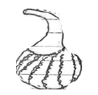
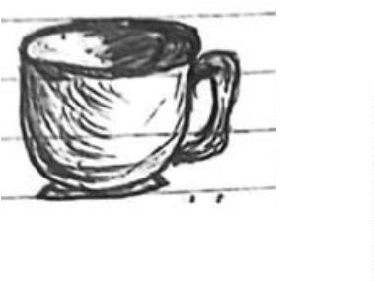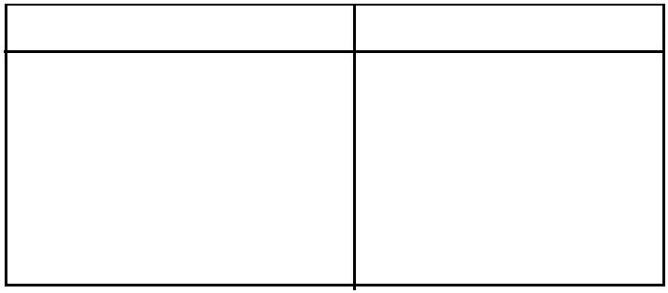

1
3. A Grade 4 Creative Arts teacher drew the
musical instrument shown below.
17. Grade 4 learners drew the following sol-fa
ladder.
Which part makes the sound louder?
f
m
x
d
Identify the sol-fa syllable represented by
letter X.
A. s
C. r
B. t
D. l
1
4. Lucas drew the note symbol as shown below.
1
8. During a Creative Arts lesson, the Grade 4
teacher demonstrated the hand sign shown
below and asked learners to interpret it.
What is its French rhythm name?
A. taa
B. ta-te
D. ta-
C. taa-aa
1
5. Grade 4 learners matched musical symbols
with their counts. Which one was wrongly
matched?
What was the correct interpretation?
A. do
B. re
D. fa
C. mi
A.
B.
C.
D.
one
1
9. Lucy was heard singing “Amkeni tujenge nchi
two
yetu.” Which type of song did she sing?
A. Patriotic
C. Topical
B. Sacred
three
four.
D. Lullaby.
20. Grade 4 learners sang a song in their
classroom. They appeared sad. How did they
demonstrate that mood? They sang
1
6. Teacher Maria wrote the following rhythm
pattern on the board.
A. softly
B. loudly
C. at a slow tempo
D. at a fast tempo
2
1. In a game of Netball, Awiti stated some of the
skills they had learnt. Which one was wrong?
How would Grade 4 learners clap it?
A. taa ta-te taa
A. Kicking
C. Catching
B. Passing
D. Shooting
B. taa taa ta-te
C. ta-te taa taa
D. taa taa taa
3
CRT/ARTS/GR. 4
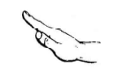

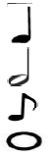
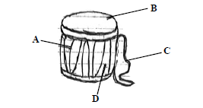
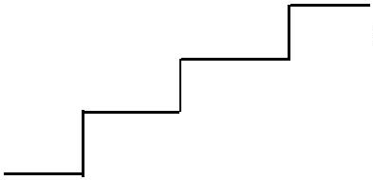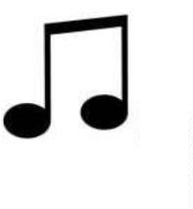

2
3
9. When performing the elongated start in
sprints, Grade four learners acquired the
skills below except
2
2
2
2. The field of netball is divided into_______
parts.
A. 2
C. 3
B. 1
D. 4
A. love
B. unity
C. tolerance
D. disobedience
0. Aluoch brought a descant recorder to class.
They learnt all the following parts of the
recorder except one. Which one?
A. Foot bar
3. Martha reminded her friends that a game of
netball has _______ players.
A. 14
C. 10
B. 12
D.15
B. Middle Joint
C. Mouth Piece
4. Leah wanted to perform a sprint. She had to
demonstrate the three techniques. Which one
was incorrect?
D. Foot joint.
A. On your mark
C. Move
B. Set
D. Go
2
5. A teacher reminded the Grade four pupils to
do all the following before running. Which
one of the following did they not do?
A. Wear appropriate clothes.
B. Warm up before running.
C. Clear the track.
D. Be crowded and push one another when
running.
2
6. Ranita performed the following skills in
Gymnastics. Which one did she not perform?
A. Crab balance
B. Elongated start
C. Side roll
D. Tank roll.
2
2
7. Ronnie reminded his class that the field of
netball is ________ in shape.
A. rectangular
C. triangular
B. circular
D. perimeter
8. Chege, an athlete in Grade 4B, can use the
medium start in all the following short races
except
A. 100 m
B. 200 m
D. 400 m
C. 1500 m
4
CRT/ARTS/GR. 4

