

K.P.S.E.A

PRIMARY SCHOOL EDUCATION ASSESSMENT

TERM 2: MIDTERM ASSESSMENT 2026
GRADE 4 – C.R.E
Time: 1 Hour 30 Minutes
LEARNER’S DETAILS
Name: ________________________________________________. School: _____________________________________________________.
Assessment Number: _________________________________. Date: ______________________________________________________.
School Code: _______________________________________. Signature: _________________________________________________.

Instructions for Learners
- Write your name, school name, and assessment number in the spaces provided.
- This paper consists of five questions.
- Check the question paper carefully to ensure all pages are printed and no questions are missing.
- Answer all the questions in the spaces provided.

FOR OFFICIAL USE ONLY -FOR EXAMINER’S USE
SECTION | SECTION A | SECTION B | % SCORE | EE1 | EE2 | ME1 | ME2 | AE1 | AE2 | BE1 | BE2
SCORE RANGE | 20 MARKS | 30 MARKS |  | 90-100 | 75-89 | 58-74 | 41-57 | 31-40 | 21-30 | 11-20 | 1-10
POINTS |  |  |  | 8 POINTS | 7 POINTS | 6 POINTS | 5 POINTS | 4 POINTS | 3 POINTS | 2 POINTS | 1 POINT
LEARNER’S TOTAL SCORE

SECTION A: (20 MARKS)
- Study the puzzle below and identify the hidden attributes of God.
C | R | E | A | T | O | R
A | L | O | V | I | N | G
B | S | T | U | V | W | X
H | O | L | Y | Y | Z | A
P | Q | R | S | T | U | V
a) List two attributes of God found in the puzzle above. (2 marks)
i) __________________________ ii) __________________________
b) According to Genesis 1:1-25, God is the Sole Creator. Name one thing God created. (1 mark)
______________________________________________________________________________
- Look at the two main parts of the Bible shown in the diagram.
THE BIBLE

NEW TESTAMENT OLD TESTAMENT

a) Which part of the Bible contains the four Gospels (Matthew, Mark, Luke, John)? (1 mark)
____________________________________________________.
b) How should a Christian handle the Holy Bible with respect? (1 mark)
___________________________________________________________________________________________
c) Write the missing word in Isaiah 49:16:
"See, I have written your name on the ___________________ of my hands." (1 mark)
- The picture below shows a man on a tree.
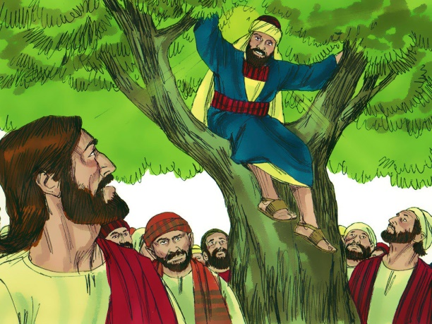
a) Identify the man on the tree. _______________________________________(1 mark)
b) Why did he climb the tree? (1 mark)
____________________________________________________________________________________.
c) State one way Zacchaeus changed his behavior after meeting Jesus. (2 marks)
______________________________________________________________________________________________________________________________________________________________________________________
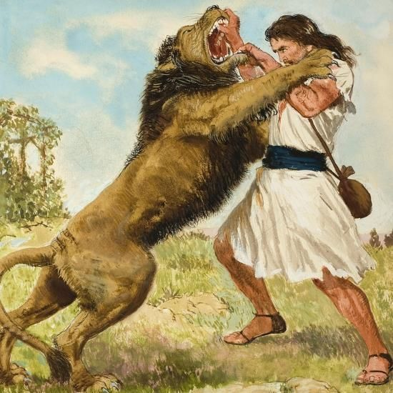
- Observe the image below.

a) Name the Bible character in the picture. ____________________________ (1 mark)
b) Where did Samson get his strength from? ________________________________________ (1 mark)
- Match the Bible character to the correct event/object related to their story. (4 marks)
Character | Event/Object
A. Abraham | i. A Talking Donkey
B. Balaam | ii. Interpreting Dreams
C. Joseph | iii. Moving from Haran to Canaan
D. Nicodemus | iv. Meeting Jesus at night
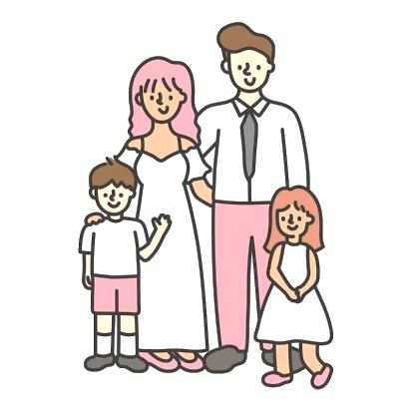
- The image below shows a type of family.

a) Identify the type of family shown above.________________________________(1 mark)
b) Name one member of the extended family not shown in the picture. (1 mark)
________________________________________.
c) According to Ephesians 6:1-3, what is the first commandment with a promise? (2 marks)
______________________________________________________________________________________________________________________________________________________________________________________

SECTION B: (30 MARKS)
- a) The Bible Say that Your body is the Temple of the Holy Spirit (1 Cor 6:19). List two ways you can protect yourself from sexual abuse. (2 marks)
i) ____________________________________________________________________________________.
ii) ___________________________________________________________________________________.
b) If someone touches you inappropriately, whom should you report to? (1 mark)
_____________________________.
c) In the story of Joseph and Potiphar’s wife, Joseph said "No" to temptation. Which Christian value did he show? (2 marks)
_________________________.
8. The image below shows a man sitting by the roadside.
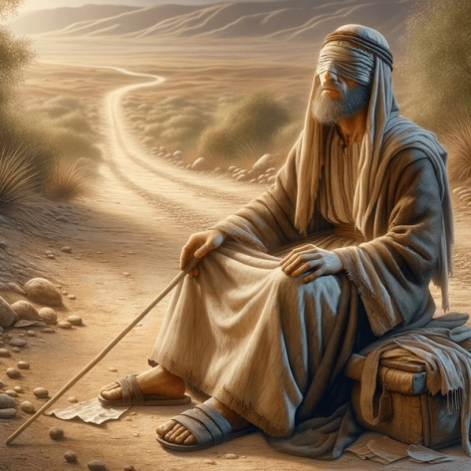
a) Identify this man. _______________________________________(1 mark)
b) What did Jesus do for him? _____________________________________________________ (1 mark)
c) In the story of the Ten Lepers, only one came back to say "Thank you."
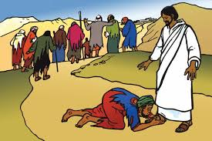
What lesson do we learn from the one who returned? (2 marks)
_________________________________________________________________________________
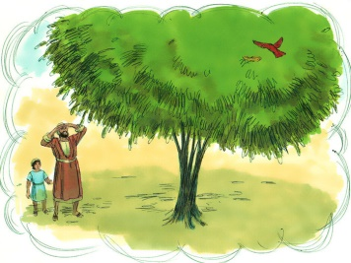
- Look at the growth cycle shown below.
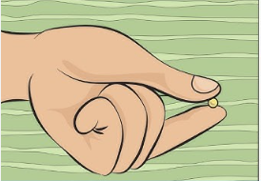
a) Which parable of Jesus is illustrated above? _____________________________________ (1 mark)
b) What does the "big tree" represent in this parable? (2 marks)
_________________________________________________________________________________________
c) In the Parable of the Lost Coin, what did the woman do when she found her coin? (2 marks)
_______________________________________________________________________________________
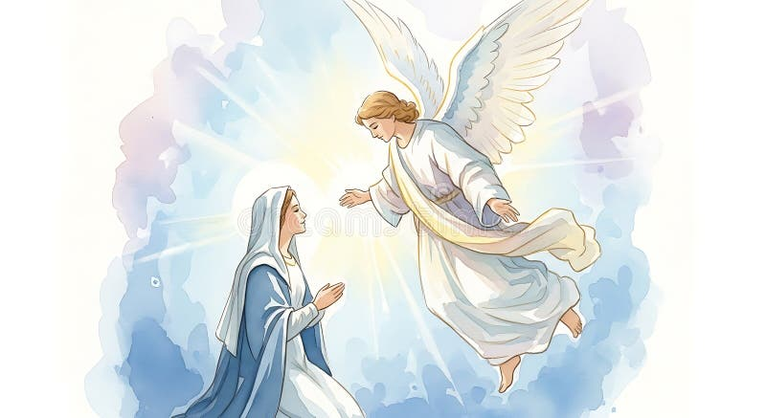
10. An Angel appeared to a Mary to inform her that she would be the mother of Jesus Christ.

a) What was the name of the Angel? ______________________________ (1 mark)
b) Name the mother of John the Baptist. _____________________________ (1 mark)
c) State two differences between the birth of Jesus and the birth of John the Baptist. (4 marks)
birth of Jesus Christ | birth of John the Baptist
11.a) According to Matthew 19:13-15, what did Jesus do to the children? (2 marks)
_____________________________________________________.
b) List two benefits of obeying our parents and teachers (Exodus 20:12). (2 marks)
i) _________________________________________________________________________. ii) _________________________________________________________________________.
c) Write one result of disobedience in school. (2 marks)
___________________________________________________________________________________________
12. Grade 4 learners should always show acts of kindness.
a) How does helping the needy show the love of God? (2 marks)
___________________________________________________________________________________________
b) Mention one way you can help a needy person in your community today. (2 marks)
__________________________________________________________________________________________

THIS IS THE LAST PRINTED PAGE

MARKING SCHEME – GRADE 4 C.R.E

SECTION A (20 MARKS)

1. Attributes of God (3 marks)

a) Two attributes (2 mks)
✔ From puzzle:
- Creator
- Loving
- Holy
✔ Any two correct = full marks

b) One thing God created (1 mk)
✔ Accept:
- Animals
- Plants
- Human beings
- Land / sky / sea

2. The Bible (3 marks)

a) Gospels found in (1 mk)
✔ New Testament

b) Respect for Bible (1 mk)
✔ Accept:
- Keep it clean
- Do not tear it
- Read it carefully
- Store it properly

c) Missing word (1 mk)
✔ Palms

3. Zacchaeus (4 marks)

a) Name (1 mk)
✔ Zacchaeus

b) Why he climbed tree (1 mk)
✔ Accept:
- To see Jesus
- He was short

c) Behaviour change (2 mks)
✔ Accept:
- Returned stolen money
- Promised to repay
- Became honest
- Followed Jesus

4. Samson (2 marks)

a) Name (1 mk)
✔ Samson

b) Source of strength (1 mk)
✔ Accept:
- God
- His hair (Nazarite vow context acceptable)

5. Matching (4 marks)
✔ Correct answers:
- A. Abraham → iii (Moving from Haran to Canaan)
- B. Balaam → i (Talking donkey)
- C. Joseph → ii (Interpreting dreams)
- D. Nicodemus → iv (Meeting Jesus at night)

6. Family (4 marks)

a) Type of family (1 mk)
✔ Accept:
- Nuclear family

b) Member not shown (1 mk)
✔ Accept:
- Grandparents
- Uncle
- Aunt
- Cousin

c) Commandment (2 mks)
✔ Honor your father and mother
✔ Accept:
- Obey your parents

SECTION B (30 MARKS)

7. Protection & Values (5 marks)

a) Protection from abuse (2 mks)
✔ Accept:
- Say NO
- Report to adult
- Avoid strangers
- Stay in safe places

b) Report to (1 mk)
✔ Accept:
- Parent
- Teacher
- Police
- Guardian

c) Value shown (2 mks)
✔ Integrity / self-control / obedience to God

8. Blind man & gratitude (4 marks)

a) Man (1 mk)
✔ Accept:
- Blind Bartimaeus
- Blind man

b) What Jesus did (1 mk)
✔ He healed him / gave him sight

c) Lesson (2 mks)
✔ Accept:
- Be thankful
- Show gratitude
- Appreciate God

9. Parables (5 marks)

a) Parable (1 mk)
✔ Accept:
- Mustard seed
- Growing seed

b) Big tree represents (2 mks)
✔ Accept:
- Kingdom of God
- Growth of faith
- Church

c) Lost coin (2 mks)
✔ Accept:
- Celebrated
- Called friends
- Rejoiced

10. Birth stories (6 marks)

a) Angel (1 mk)
✔ Angel Gabriel

b) Mother of John (1 mk)
✔ Elizabeth

c) Differences (4 mks)
✔ Accept any TWO clear differences:
Jesus | John
Born of Virgin Mary | Born of Elizabeth
Son of God | Prophet
Angel Gabriel appeared to Mary | Angel appeared to Zechariah
Birth announced differently | Born to old parents

11. Children & obedience (6 marks)

a) What Jesus did (2 mks)
✔ Accept:
- Blessed them
- Laid hands on them
- Welcomed them

b) Benefits (2 mks)
✔ Accept:
- Long life
- Blessings
- Success

c) Result of disobedience (2 mks)
✔ Accept:
- Punishment
- Failure
- Trouble

12. Kindness (4 marks)

a) Showing God’s love (2 mks)
✔ Accept:
- Helping others
- Caring for needy
- Sharing

b) One way to help (2 mks)
✔ Accept:
- Give food
- Share clothes
- Help with work
- Visit sick

PERFORMANCE LEVEL GUIDE
Level | Description
EE | Excellent understanding, accurate responses
ME | Good understanding, minor errors
AE | Basic understanding
BE | Limited understanding

