

K.P.S.E.A

PRIMARY SCHOOL EDUCATION ASSESSMENT

TERM 2: MIDTERM ASSESSMENT 2026
GRADE 5 – AGRICULTURE
Time: 1 Hour 30 Minutes
LEARNER’S DETAILS
Name: ________________________________________________. School: _____________________________________________________.
Assessment Number: _________________________________. Date: ______________________________________________________.
School Code: _______________________________________. Signature: _________________________________________________.

Instructions for Learners
- Write your full name and assessment number in the spaces provided above.
- Indicate your school name and school code clearly. Sign and date this paper in the spaces provided.
- This paper consists of TWO sections: Section A and Section B.
- Answer ALL questions in BOTH sections.
- Write your answers in the spaces provided in this question paper.
- Do NOT remove any page from this paper.
- All responses must be written in English
FOR OFFICIAL USE ONLY -FOR EXAMINER’S USE
SECTION | SECTION A | SECTION B | % SCORE | EE1 | EE2 | ME1 | ME2 | AE1 | AE2 | BE1 | BE2
SCORE RANGE | 30 MARKS | 20 MARKS |  | 90-100 | 75-89 | 58-74 | 41-57 | 31-40 | 21-30 | 11-20 | 1-10
POINTS |  |  |  | 8 POINTS | 7 POINTS | 6 POINTS | 5 POINTS | 4 POINTS | 3 POINTS | 2 POINTS | 1 POINT
LEARNER’S TOTAL SCORE

SECTION A (20 MARKS) Answer ALL questions in this section
- Farmers use different methods to conserve water on the farm.
List two methods used to conserve water during farming. (2 marks)
i. __________________________________________.
ii. __________________________________________.
- Domestic animals play different roles in the society.
Name two domestic animals and state one use of each. (2 marks)
 | Domestic animal | Its use
i.
ii.
- Wild animals sometimes destroy crops on farms. Explain two safe ways farmers can use to scare away wild animals without harming them. (2 marks)
i. __________________________________________
ii. __________________________________________
- Farmers grow different crops depending on soil and climate conditions.
Name three crops suitable for kitchen gardening. (3 marks)
i. __________________________________________
ii. __________________________________________
iii. _________________________________________
- Kitchen gardens need proper care for good production.
State three ways of caring for container gardens. (3 marks)
i. __________________________________________
ii. __________________________________________
iii. _________________________________________
- Below are farm tools used in agriculture.
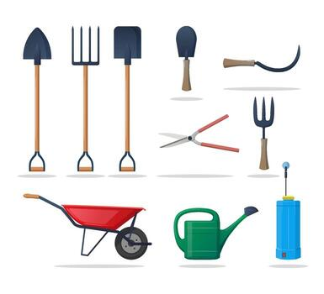

Q R S
(a) Name the tools shown/drawn below. (3 marks)
Q. _____________________. R. _______________________. S. _________________________.
(b) State one use of each tool shown below. (3 marks)
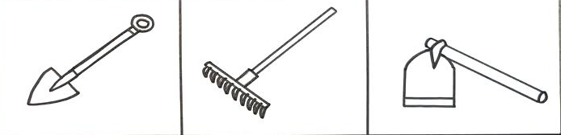
E F G
Tool | Its use in the farm
E
F
G
(c) State three safety measures to observe when using farm tools. (3 marks)
i. __________________________________________
ii. __________________________________________
iii. _________________________________________
- Farmers use different methods to conserve soil and prevent erosion.
Describe one method used to conserve soil. (2 marks) ________________________________________________________________________________________________________________________________________________________________________________
- In crop production, some seedlings are removed to allow proper growth. What is thinning? (2 marks) ________________________________________________________________________________________________________________________________________________________________________________

- Farmers use different methods to plant seeds.
Name three methods of sowing seeds on a seedbed. (3 marks)
i. __________________________________________
ii. __________________________________________
iii. _________________________________________
- Plants can be grown using different planting materials.
Name crops grown using the following planting materials: (2 marks)
a. Seeds: ____________________________________
b. Stem cuttings: _____________________________
SECTION B
Answer all questions in this section
- State whether each of the following is a healthy or unhealthy practice: (5 marks)
a. Eating fruits without washing them: _______________________
b. Washing vegetables before cooking: _______________________
c. Drinking contaminated water: _____________________________
d. Eating soil or stones: ___________________________________
e. Opening windows while sweeping the house: ________________
- Farmers in dry areas use different methods to ensure crops get enough water during dry seasons.
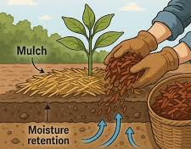

What is the name of the practice of covering soil around crops with dry grass or organic matter? (1 mark)
_________________________________________________.
- Wild animals are important natural resources that need protection from human activities.
State True or False. (2 marks)
i) Fencing farms helps prevent wild animals from destroying crops. __________
ii) It is acceptable to hunt wild animals for fun. __________
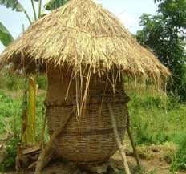
- After harvesting maize, a farmer stores it to prevent damage by pests and rotting.

a) Name the traditional structure used for storing grains. _________________________________________(1 mark)

b) Match the cooking method to its correct description. (3 marks)
Method | Description
Boiling | Cooking food in hot oil or fat
Frying | Cooking food in a lot of water at high temperature
Steaming | Cooking food using steam or a small amount of water
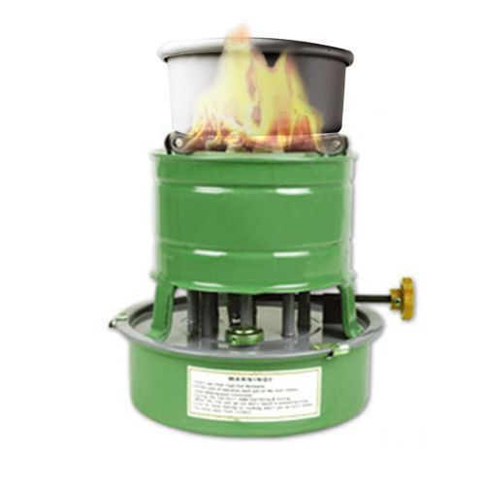
c) Identify the cooking fuel shown in the diagram below. (1 mark)

_____________________________________.
d) List two items used for personal grooming. (2 marks)
i. __________________________________________________________
ii. __________________________________________________________
- A stain is a mark on clothes that is difficult to remove.
a) Which is the best way to remove a blood stain? (1 mark)
A. Use very hot water
B. Soak in cold salty water
C. Use a hot iron
(Write the correct answer) ______________________
b) State two precautions when using chemicals like bleach. (2 marks)
i. __________________________________________________________
ii. __________________________________________________________
c) Name one natural substance used to remove stains at home. (1 mark)
______________________________________________________________________________________________________________________________________________________________________________________
d) Why is it important to keep hair clean and neat? (1 mark)
______________________________________________________________________________________________________________________________________________________________________________________

THIS IS THE LAST PRINTED PAGE

ANSWERS

GRADE 5 AGRICULTURE

SECTION A

1. Water conservation methods (ANY 2)
Accept any two:
i. Mulching
ii. Rainwater harvesting
iii. Irrigation (drip/sprinkler)
iv. Water harvesting pits
v. Planting drought-resistant crops
vi. Use of water pans
vii. Contour farming

2. Domestic animals and uses (ANY 2 pairs)
Domestic animal | Possible uses
Cow | Milk, meat, manure, leather
Goat | Milk, meat, skin
Chicken | Eggs, meat
Sheep | Wool, meat
Donkey | Transport, carrying loads
Camel | Transport, milk

3. Safe ways of scaring wild animals (ANY 2)
i. Building fences (live or wire)
ii. Using scarecrows
iii. Making noise (drums, bells, shouting)
iv. Using guard dogs
v. Using flashing lights
vi. Using smoke or fire at night
vii. Planting strong-smelling plants

4. Kitchen gardening crops (ANY 3)
i. Spinach
ii. Sukuma wiki (kales)
iii. Tomatoes
iv. Onions
v. Coriander (dhania)
vi. Cabbage
vii. Lettuce
viii. Carrots
ix. Capsicum
x. Beans

5. Care of container gardens (ANY 3)
i. Regular watering
ii. Weeding
iii. Applying manure/fertiliser
iv. Proper drainage
v. Placing in sunlight
vi. Pest control
vii. Pruning/removing dry leaves
viii. Using good soil

6(a) Farm tools (depends on diagram)
Common answers learners may give:
- Q: Wheelbarrow
- R: Watering can
- S: Sickle

6(b) Uses of tools (ANY correct use)

Spade – Uses
- Digging holes for planting trees and crops
- Turning and loosening soil
- Transferring soil, sand, or manure
- Mixing compost or farm materials
- Making planting beds

Rake – Uses
- Leveling the soil after digging
- Collecting stones, roots, and debris
- Breaking small soil clods
- Covering seeds lightly with soil
- Gathering grass or dry leaves

Jembe (Hoe) – Uses
- Digging and loosening soil
- Weeding around crops
- Making planting holes and furrows
- Earthing up crops (covering roots with soil)
- Mixing manure with soil
- Removing weeds in a garden
- Loosening soil around plants
- Digging small planting holes
- Making ridges and furrows
- Preparing seedbeds

6(c) Safety measures (ANY 3)
i. Wear protective clothing (gloves/boots)
ii. Handle tools carefully
iii. Store tools safely after use
iv. Keep tools clean
v. Do not use broken tools
vi. Carry tools properly (pointing downwards)
vii. Do not play with tools

8. Soil conservation methods (ANY ONE explained)
Accept:
- Mulching (covering soil to reduce erosion and conserve moisture)
- Terracing (making steps on slopes to reduce soil washing)
- Contour farming (ploughing across slope)
- Planting trees/grass (bind soil)
- Strip cropping
- Cover cropping
- Crop rotation
- Building gabions

9. Thinning
Any correct explanation:
- Removal of extra seedlings to reduce overcrowding
- Removing weak plants so strong ones grow well
- Leaving enough space between plants for growth
- Uprooting unwanted seedlings in a seedbed

10. Methods of sowing seeds (ANY 3)
i. Broadcasting
ii. Drilling
iii. Dibbling
iv. Transplanting seedlings
v. Row planting
vi. Hole planting

11. Planting materials
a. Seeds (ANY): maize, beans, rice, sorghum, millet, peas
b. Stem cuttings (ANY): sugarcane, cassava, sweet potato, napier grass, rose flowers

SECTION B

12. Healthy / Unhealthy practices
a. Unhealthy
b. Healthy
c. Unhealthy
d. Unhealthy
e. Healthy
(Also accept: “good/bad practice” wording)

13.
i. Mulching

14. True / False
i. True
ii. False
(also accept correct reasoning if explained)

15(a) Grain storage structure
Accept:
- Granary

15(b) Matching (CORRECTED)
Correct answers:
- Boiling → Cooking food in a lot of water at high temperature
- Frying → Cooking food in hot oil or fat
- Steaming → Cooking food using steam or small amount of water

15(c) Cooking fuel (depends on diagram)
Accept:
- LPG gas

15(d) Personal grooming items (ANY 2)
i. Comb
ii. Toothbrush
iii. Soap
iv. Nail cutter
v. Hair brush
vi. Towel
vii. Razor (for older learners in context)

16(a) Blood stain removal
Correct answer:
- B. Soak in cold salty water
Also acceptable:
- Cold water only
- Cold soapy water

16(b) Precautions when using bleach (ANY 2)
i. Wear gloves
ii. Avoid contact with skin/eyes
iii. Do not mix with other chemicals
iv. Use in well-ventilated area
v. Keep away from children
vi. Read instructions

16(c) Natural stain remover (ANY 1)
Accept:
- Lemon juice
- Ash
- Baking soda
- Salt
- Soap (traditional)
- Vinegar
- Sand (for scrubbing clothes in rural context)

16(d) Importance of clean hair
Accept:
- Prevents lice and dandruff
- Maintains hygiene
- Makes hair neat and presentable
- Prevents bad smell
- Promotes health and confidence

