NAME…………………………………………….. ADM:……………… SCHOOL…………………………………………. CLASS. ……………..
DATE. ……………………………… SIGN: ………………….

443/1
AGRICULTURE
PAPER 1
July 2026
2 Hours
PALMS SCHOOLS
JOINT EXAMINATION
KENYA CERTIFICATE OF SECONDARY EDUCATION
AGRICULTURE
INSTRUCTIONS TO CANDIDATES
- Write your name and admission number in the spaces provided
- Sign and write the date of examination in the space provided above.
- This paper consists of three sections: A , B and C.
- Answer all the questions in sections A and B.
- Answer any two questions from section C.
- Answers should be written in the space provided.
- This paper consists of 12 printed pages.
- Candidates should check the question paper to ascertain that all the pages are printed as indicated and that no questions are missing.
For Examiner’s Use Only
Section | Question | Maximum score | Candidates Score
A | 1-16 | 30
B | 17-20 | 20
C |  | 20
 |  | 20

Section A: Answer all questions in this section.
- State four disadvantages of using suckers as planting materials. (2mks)
……………………………………………………………………………………………………………………………………………………………………………………………………………………………………………………………………………………………………………………………………………………
- Give four reasons for sub soiling in land preparation. (2 marks)
…………………………………………………………………………………………………………………………………………………………………………………………………………………………………………………………………………………………………………………………………………………………………………………………………………………………………………
- State four pieces of information found on animal health records. (2 marks)
…………………………………………………………………………………………………………………………………………………………………………………………………………………………………………………………………………………………………………………………………………………………………………………………………………………………………………
- State three advantages of applying Nitrogenous fertilizers in splits. (1½ marks)
……………………………………………………………………………………………………………………………………………………………………………………………………………………………………………………………………………………………………………………………………………………
- Name three examples of settlements under Million Acre Scheme. (1½ marks)
……………………………………………………………………………………………………………………………………………………………………………………………………………………………………………………………………………………………………………………………………………………

- List four examples of French beans varieties grown for green pods. (2 marks)
…………………………………………………………………………………………………………………………………………………………………………………………………………………………………………………………………………………………………………………………………………………………………………………………………………………………………………
- State four factors that influence soil formation. (2 marks)
…………………………………………………………………………………………………………………………………………………………………………………………………………………………………………………………………………………………………………………………………………………………………………………………………………………………………………
- Name four sites for growing for Agroforestry trees. (2 marks) ………………………………………………………………………………………………………………………………………………………………………………………………………………………………………………………………………………………………………………………………
- State four pieces of information contained in a delivery note. (2 marks) ………………………………………………………………………………………………………………………………………………………………………………………………………………………………………………………………………………………………………………………………
- Give four reasons for draining water logged soil as a method of land reclamation. (2 marks) ………………………………………………………………………………………………………………………………………………………………………………………………………………………………………………………………………………………………………………………………………………………………………………………………………………
- State four advantages of adding organic manure to sandy soil. (2 marks) ………………………………………………………………………………………………………………………………………………………………………………………………………………………………………………………………………………………………………………………………………………………………………………………………………………
- Give two features of a tree appropriate for intensive hedgerow practice. (1 mark) ………………………………………………………………………………………………………………………………………………………………
- State four characteristics of a good vegetable seedling. (2 marks)
………………………………………………………………………………………………………………………………………………………………………………………………………………………………………………………………………………………………………………………………
- Give four factors that determine the stage at which a crop is harvested. (2 marks) ………………………………………………………………………………………………………………………………………………………………………………………………………………………………………………………………………………………………………………………………………………………………………………………………………………………………………………………………
- State four physical features used to control soil erosion. (2 marks) ………………………………………………………………………………………………………………………………………………………………………………………………………………………………………………………………………………………………………………………………………………………………………………………………………………………………………………………………………………………………
- List four activities that may be undertaken in organic farming. (2 marks) ………………………………………………………………………………………………………………………………………………………………………………………………………………………………………………………………………………………………………………………………
SECTION B.
- The diagrams below show weeds G and H.
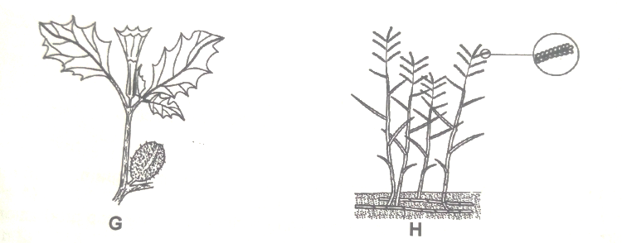
- Identify the weeds G and H. (2 marks)
G. …………………………………… H: ……………………………………
- State the economic importance of each of the weed shown above. (2 marks)
G. ………………………………………………………………………………
H. ………………………………………………………………………………
- Give a reason why it is difficult to control weed in diagram H. (1 mark)
………………………………………………………………………………………………………………………………………………………………
- The illustration below shows a method of propagation in crop production.
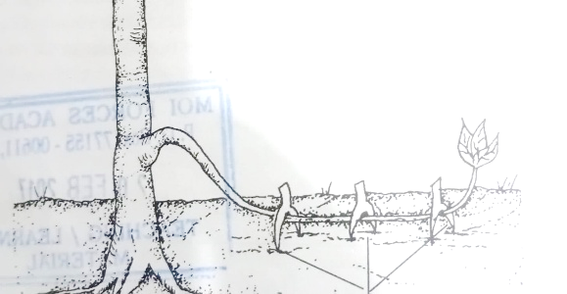

- Name the method shown above. (1 mark)
……………………………………………………………………………
- State two advantages of the above method of propagation. (2 marks)
………………………………………………………………………………………………………………………………………………………………………………………………………………………………………
- State two advantages of tissue culture. (2 marks)
………………………………………………………………………………………………………………………………………………………………………………………………………………………………………
- The diagrams illustrated below shows pests which attack maize . Study them carefully and answer the questions that follow.
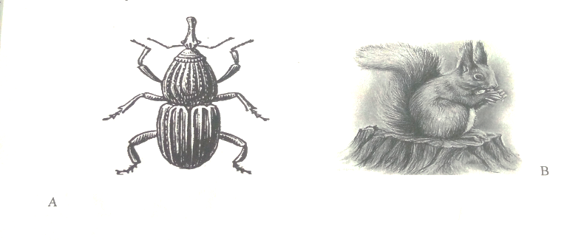
- Identify the pests labelled A and B. (2 marks)
A.………………………………………………………………………………
B.……………………………………………………………………………
- At what stage of maize production does each pest damage the crop? (2 marks)
………………………………………………………………………………………………………………………………………………………………
- Give one way of controlling each of the pest in the field. (1 mk)
………………………………………………………………………………………………………………………………………………………………………………………………………………………………………………
- Use the diagram below to answer the questions that follow.
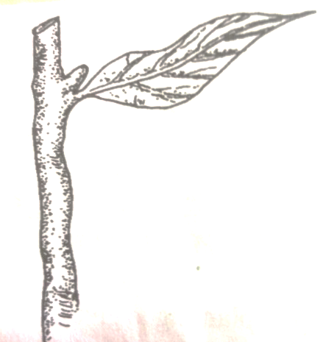
- Identify the above planting material. (1 mark)
……………………………………………………………………………
- State two factors to consider when obtaining the above material from the parent plant. (2 marks)
………………………………………………………………………………………………………………………………………………………………………………………………………………………………………
- State two factors which determine the rooting of the above planting material. (2mks)
………………………………………………………………………………………………………………………………………………………………………………………………………………………………………
SECTION C
- a). Describe 5 field management practices for cabbage production. (5mks)
b). Outline 5 precautions that a farmer should observe when harvesting pyrethrum. (5mks)
c). Describe 5 ways in which a farmer adjusts to risks and uncertainties . (5mks)
d). Explain 5 practices that a farmer should carry to uniform germination of seeds. (5mks)
- a). Explain six factors considered when designing a crop rotation program. (6mks)
b). Give six reasons why land consolidation should be encouraged in Kenya. (6mks)
c). The following is a farm record Mrs. Sanda had kept as at 30th June 2006. Study it carefully and answer the questions that follow.
Cash at hand 20,000
Cash at bank 66,000
Buildings 50,000
Disc plough 16,000
Debtors 16,000
Working tools 12,000
Bank overdraft 24,000
Creditors 20,000
Loan 50,000
Cattle 40,000
Land 80,000
- Prepare a balance sheet from the above information for Mrs. Sanda farm. (6mks)
- Give two importance of balance sheet to Mrs. Sanda . (1mk)
- Is Mrs. Sanda’s farm solvent or insolvent ? Give a reason. (1mk)
23. Explain two ways in which each of the following factors influence crop production.
i)Relative humidity. (2mks)
ii)Light. (2mks)
iii)Temperature. (2mks)
b)Explain 5 principles that govern the formation and function of cooperative societies in Kenya. (5mks)
c)Explain 5 cultural methods of controlling weeds in maize farm. (5mks)
d)Describe 4 nursery management practices carried out in raising agroforestry tree seedlings. (4mks)

……………………………………………………………………………………………………………………………………………………………………………………………………………………………………………………………………………………………………………………………………………………………………………………………………………………………………………………………………………………………………………………………………………………………………………………………………………………………………………………………………………………………………………………………………………………………………………………………………………………………………………………………………………………………………………………………………………………………………………………………………………………………………………………………………………………………………………………………………………………………………………………………………………………………………………………………………………………………………………………………………………………………………………………………………………………………………………………………………………………………………………………………………………………………………………………………………………………………………………………………………………………………………………………………………………………………………………………………………………………………………………………………………………………………………………………………………………………………………………………………………………………………………………………………………………………………………………………………………………………………………………………………………………………………………………………………………………………………………………………………………………………………………………………………………………………………………………………………………………………………………………………………………………………………………………………………………………………………………………………………………………………………………………………………………………………………………………………………………………………………………………………………………………………………………………………………………………………………………………………………………………………………………………………………………………………………………………………………………………………………………………………………………………………………………………………………..………………………………………………………………………………………………………………………………………………………………………………………………………………………………………………………………………………………………………………………………………………………………………………………………………………………………………………………………………………………………………………………………………………………………………………………………………………………………………………………………………………………………………………………………………………………………
……………………………………………………………………………………………………………………………………………………………………………………………………………………………………………………………………………………………………………………………………………………………………………………………………………………………………………………………………………………………………………………………………………………………………………………………………………………………………………………………………………………………………………………………………………………………………………………………………………………………………………………………………………………………………………………………………………………………………………………………………………………………………………………………………………………………………………………………………………………………………………………………………………………………………………………………………………………………………………………………………………………………………………………………………………………………………………………………………………………………………………………………………………………………………………………………………………………………………………………………………………………………………………………………………………………………………………………………………………………………………………………………………………………………………………………………………………………………………………………………………………………………………………………………………………………………………………………………………………………………………………………………………………………………………………………………………………………………………………………………………………………………………………………………………………………………………………………………………………………………………………………………………………………………………………………………………………………………………………………………………………………………………………………………………………………………………………………………………………………………………………………………………………………………………………………………………………………………………………………………………………………………………………………………………………………………………………………………………………………………………………………………………………………………………………………………………………………………………………………………………………………………………………………………………………………………………………………………………………………………………………………………………………………………………………………………………………………………………………………………………………………………………………………………………………………………………………………………………………………………………………………………………………………………………………………………………………………………..……………………………………………………………………………………………………………………………………………………………………………………………………………………………………………………………………………………………………………………………………………………………………………………………………………………………………………………………………………………………………………………………………………………………………………………………………………………………………………………………………………………………………………………………………………………………………………………………………………………………………………………………………………………………………………..………………………………………………………………………………………………………………………………………………………………………………………………………………………………………………………………………………………………………………………………………………………………………………………………………………………………………………………………………………………………………………………………………………………………………………………………………………………………………………………………………………………………………
……………………………………………………………………………………………………………………………………………………………………………………………………..……………………………………………………………………………………………………………………………………………………………………………………………………………………………………………………………………………………………………………………………………………………………………………………………………………………………………………………………………………………………………………………………………………………………………………………………………………………………………………………………………………………………………………………………………………………………………………………………………………………………………………………………………………………………………………..………………………………………………………………...
This is the last printed page

